Consulting children
Hinckley & Bosworth Borough Council
Community safety
Telephone: 01455 255746

Contents
Consulting children 1
Children’s consultation 4
Approach 4
Barriers 5
Clear aims 5
Questions 5
Why is listening and participation important? 5
Location of Scheme 6
Age Range: 6
Ethnicity/Gender Monitoring 7
A world for children 8
Equipment: 8
Consultation plan 8
Message in a bottle 9
Consultation plan 9
Treasure chest 10
Equipment: 10
Consultation plan 10
Dream clouds 11
Equipment: 11
Consultation plan 11
Thought shower 12
Equipment: 12
Consultation plan 12
Graffiti wall 13
Equipment: 13
Consultation plan 13
It will come out in the wash 13
Equipment: 13
Consultation plan 13
Ideas tree 14
Equipment: 14
Consultation plan 14
Jigsaw 15
Equipment: 15
Consultation plan 15
Four corners 16
Equipment: 16
Consultation plan 16
Role play 17
Equipment: 17
Consultation plan 17
Survey sheets 18
Survey Sheet 1 19
Survey Sheet 2 20

Children’s consultation
“The process of sharing decisions which affect one’s life and the life of the community in which one lives. It is a means by which a democracy is built and it is a standard against which democracies are measured. Participation is the fundamental right of citizenship.” (Hart 1992)
A child-centred approach is key, by looking at the world from a child’s point of view and not taking a view that ‘adults know best’.
Play should empower children, affirm and support their right to make choices, discover their own solutions and develop at their own pace.
Adults sometimes feel that they have to take total control and responsibility for decisions because of children’s lack of experience.
Real participation includes the opportunity to express views and contribute to the process.
Children are the experts at being children; they know what they want and need and the things that would interest those most.
By involving children from the out set, we can benefit from their expertise and create a strategy that is more likely to be effective and successful.

Approach
This information pack is intended as a guide. The methods are child-centred in their approach and the processes are designed to empower and stimulate children. They are all flexible and can be adapted to suit age and ability.
The children are encouraged to think, discover and express themselves in many different ways.
Play is central to the approach taken in this pack. The activities allow children to have fun and using creative ideas thinking out side of the box.
Each idea has a time guide allocated but this is only a guide and if the children take the activity to a different level this is fantastic and should be encouraged.

Barriers
Certain factors can inhibit children’s participation. It is important to be aware of these and remove or minimise them. For example:
- Children’s confidence in speaking out
- Language barriers and use of jargon
- Competing with other activities
- Insufficient resources
- Beliefs
- Lack of information
- Inappropriate methods

Clear aims
Having clear aims and objectives is a really important part of the process. Talking through the issues and how they will impact on the children and young people.
When consulting with children and young people it is essential to be honest and realistic. The participants need to know what will happen to their thoughts and ideas and how potentially they may be implemented.
Along side the key questions it is also important to gather other data to inform the process. This is in terms of age, gender, ethnicity disability and location.

Questions
It is important that there are clear questions that form the basis of the consultation. These may be used in a questionnaire or survey style or used to underpin discussion and games.
They need to be simple, age appropriate and measurable.

Why is listening and participation important?
It is becoming more and more difficult for children to play as freely as their parents did. Expanding road networks, increased traffic, pressure on parents to take their children to activities after school, loss of green space and fears for children’s safety can all have huge detrimental effects on a child’s freedom to play and therefore the skills they develop through playing.
As adults we may also remember restrictions but we also remember the freedom we may have had in our play. Play spaces were places for making mistakes and learning from them, taking risks, making choices, exploration and freedom.
With changes in society, working patterns, a decrease in extended family networks and close-knit communities these have all made their mark on children’s lives.
Children have lost their freedom and control over many basic requirements and are loosing the ability to make judgements or feel they have any ‘say’ in what is happening in their lives.
It is essential that children and young people are supported to build skills, confidence and their capacity to make change happen. They have a right to be not just heard but listened to by adults and the wider community. They are the adults and citizens of the future.
Gathering and recording information
Throughout all of the consultation activities it is important to gather the information effectively and record the data, to enable good evaluation and findings.
Some examples of methods to use:
- Observation
- Written evidence
- Photographs
- Children’s work
- Questionnaires
- Tape recordings
- Video
- Graffiti Wall
- Pro-forma
Just be aware of getting consent for any photo’s or video work.
Below is an example of a simple pro-forma to help gather more specific information about the children being consulted. It is recommended that a new form be used for every activity to keep it simple.

Location of Scheme

Age Range:
- Three to five years
- Five to eight years
- Eight years plus

Ethnicity/Gender Monitoring
- Female
- Male
- Disabled

- Asian or Asian British
- Black or Black British
- Mixed
- White
- Chinese
- Other

A world for children
Time can range from 15 minutes to 45 minutes.
Can be adapted to suit all ages.

Equipment:
- Junk Materials
- Glue
- Paint and brushes
- Felt pens
- Paper
- Collage bits

Consultation plan
- Think about the purpose of your consultation.
- Talk about the future, what do we want it to be like? What would make us happy? What could we change?
- Get the children to think about what they would change if they could.
- Ask the children to design in 3D or 2D a model of something they want for the future.
- When the models/ drawing are finished ask the children to explain and take photographs or video.
This exercise can be used in a number of ways; to design home corners and role-play areas.
Help to change outdoor space.
Re-design reception areas.
To take this further you may like to encourage them to write stories, scripts, songs or poems around their ideas.
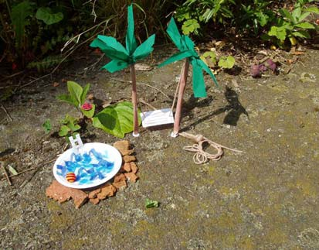

Message in a bottle
This can be left out over a long time frame, for children to participate when they feel they might want too.
Can be adapted for any age group, can be done pictorially.
Equipment:
- Different plastic bottles
- Paddling pool
- Paper
- Pens, crayons, paint
- Glitter and collage materials

Consultation plan
- Children can choose a plastic bottle of any shape or size.
- If they want to decorate the bottles that can extend this activity.
- Choose the question you want to consult on and either talk it through or have it displayed by the activity.
- Explain to the children that you would like their thoughts and ask them to make sue they put down their name and age on their message.
- The children can produce a message with pens and paper, pictures, decoupage, glitter etc. etc. This can be as simple or elaborate as you wish.
- They then need to roll up the message and put it inside the bottle (bottles need to be dry!)
- They can then throw it into the sea…. Or paddling pool!
To extend this you could ask that they launch it from the pirate’s boat and base it around a whole role play activity, and for older young people they could write songs, poems or stories.
Another variation to this is a type of time capsule that you could bury in the sand pit.
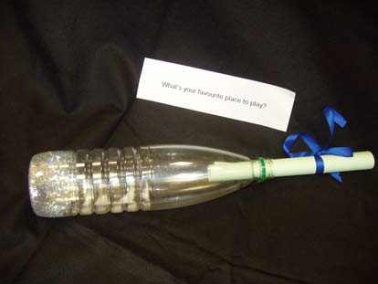

Treasure chest
Once you have made your treasure chest this activity can be left out for children to participate throughout the day.
This can be adapted to suit most age groups.

Equipment:
- Boxes
- Paper
- Pens
- Craft bits
- Scissors
- Glue

Consultation plan
- This activity starts with making the treasure chest, which can be as simple or elaborate, as you want to make it.
- The question you are consulting on needs to be agreed and either explained or written so the children are able to understand.
- The children can make treasure shapes from paper or junk, and then write or draw their feelings onto the items.
- They must then put the treasure into the chest.
- It is important that the child puts down their name so you are able to record specific information about who took part.
This can be used in many ways, you may want a post box or an animal to feed, the possibilities are endless.
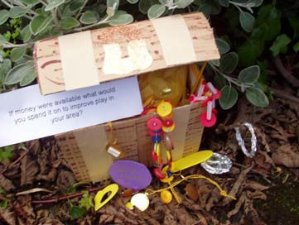

Dream clouds
Allow 20 minutes to an hour.
Aimed at over fives.

Equipment:
- Paper
- Pens
- Scissors
- Collage items
- Cotton wool
- Glue
- Laminator (optional)
- Camera (optional)

Consultation plan
- Think of the question you want to pose to the children. This works well with questions based on ‘if you won the lottery…’ or ‘if you had a magic wand…’
- Get them to draw their own dream cloud and write and draw their thoughts. If you want to take their photo to put at the centre of the cloud this makes it really personal.
- Laminate if you want too and if appropriate.
- Display.
- Encourage the children to make the backdrop of a sky scope.
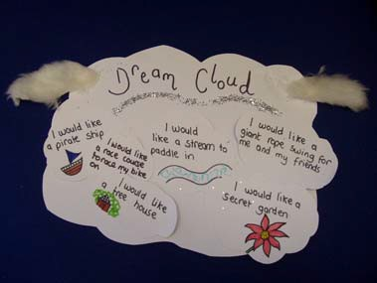

Thought shower
Allow 15 minutes to an hour.
Most suitable for over fives.

Equipment:
- Scissors
- Glue
- Paper
- Laminator (optional)
- Craft items
- String or wool
- Photos

Consultation plan
- First choose your question or subject that you want to consult the children on and discuss this with them.
- Make your umbrella or wellies to go at the top of your thought shower.
- Make small cards or raindrops with the thoughts ideas and comments on.
- String these together to make a mobile.
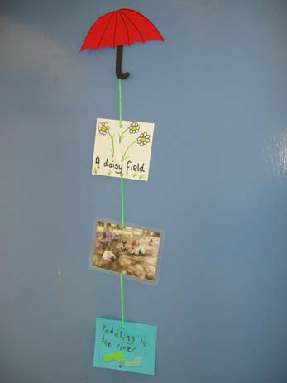

Graffiti wall
This is a quick activity but can be left out for long periods.
Suitable for most age groups.

Equipment:
- Chalk
- Wall
- Pavement
- Large Board
- Card

Consultation plan
- You can begin by writing up the question onto your wall or board.
- Ask the children to write or draw their thoughts onto the wall, pavement or board.
- Ask them to sign their names and ages, and then take photographs as evidence.
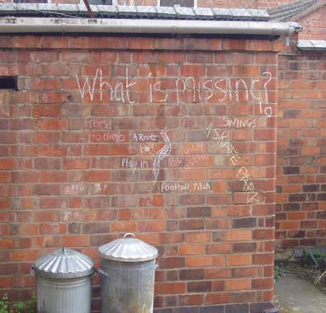

It will come out in the wash
15 minutes to 30 minutes
Can be adapted to suit different age groups

Equipment:
- Junk
- Fabric
- Pens
- Craft materials
- Scissors
- Glue
- String

Consultation plan
- Choose the question you want to use to consult the children.
- Make a washing machine from junk.
- Using fabric, such as small old socks, ask the children to draw or write their thoughts onto the item.
- Post them to be washed.
- Empty the machine and hang the thoughts out to dry.
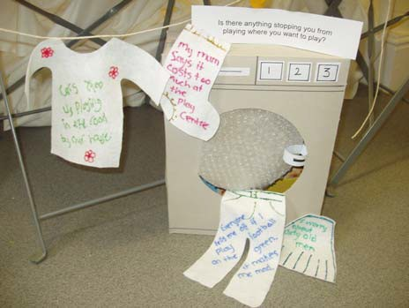

Ideas tree
Ongoing, can be left to add to.
Can be adapted to suit different age groups.

Equipment:
- A real branch
- Pens
- Paper
- Card
- Leaf shapes
- Glue
- Scissors

Consultation plan
- Think about the question and aim of the tree.
- Either draw a 2D tree shape or be more creative by using an old branch or maybe even a Christmas tree.
- Talk to the children or pose the question by another method for example pin up the question by the tree.
- Collate the leaves.
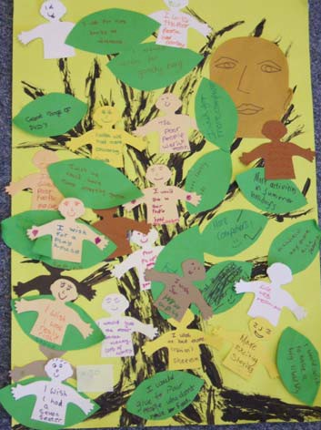

Jigsaw
Can be done individually or part of a larger project in about an hour.
Suitable for five years and upwards depending on complexity and detail.

Equipment:
- Scissors/ craft knife
- Paper
- Pens
- Paint
- Glue
- Photos/ magazines/leaflets
- Large piece of foam or card

Consultation plan
- Explain to the children that you are going to make a jigsaw, based on a theme. (this may be a specific question or general theme)
- Organize opportunities for the children to gather information and material to make their jigsaw. Visit interesting place, take photos or have discussions.
- Make different resources available for children, books, images, facts, and articles.
- To create the jigsaw, get the children to build up a montage of all their drawings, photos etc on to a large piece of card.
- Glue them in place; if you have access to a laminator you may want to laminate them.
- Ask the children to draw out their jigsaw design onto the back of the card.
- Cut out the jigsaw and keep all the pieces together. You can be inventive around this and ask them to decorate bags or boxes to keep their jigsaws in.
To extend this idea, you could ask the children to work in teams and then swap jigsaws with each other, this could generate interesting discussion.
You may wish to take it further by posing specific questions
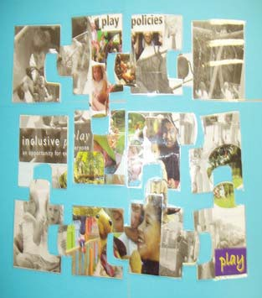

Four corners
Can be played for as long as the children enjoy it.
Can be adapted to suit most age groups.

Equipment:
- General sports equipment
- Other props relevant to the game

Consultation plan
This game is very simple and can be adapted in a number of ways; it can be changed easily to suit different children.
- Choose which questions you are consulting on.
- Give each side of the room or corner a specific response. For example if you were asking the children ‘What colour paint shall we paint the hall?’ If they run to one side it could be yellow, the other green.
This game can be adapted creatively and can incorporate other simple ideas.
- Rather than the four corners, you could have four expressions.
- Have visual aids available to give the game some differentiation.
- Use balls and ask them to place them into the basket in the relevant corner.
- Use hoops and ask them to throw bean bags.
- Use musical instruments or mimes.
- Make a compass on the floor, North is exciting, south is wicked etc.
These are just a few simple ideas; these could go on and on, use your imagination to come up with different ideas.
These games have immediate responses, so it might be a good idea to have a volunteer taking down the tally.
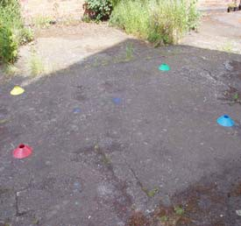

Role play
As long or short as the children want.
This could be adapted to suit most age groups.

Equipment:
- Props
- Costumes
- Cloth
- Pegs
- Puppets

Consultation plan
- Once you have decided the question or issue you want to consult on, you need to look at the age of the children to determine what method would be most appropriate.
- Give the children costume props etc and then give them characters, for example a parent, teacher or play worker. To suit the issue you want to explore.
- If the children are able they may want to write a script to go with their drama.
- If you are working with younger children, it may work well if you use a puppet to ask questions. This can work particularly well if it is a more sensitive issue such as bullying.
Puppets work very well with children developing a performance, script and even their own puppets relating to a particular issue.
It is often best to record, or photograph to evaluate at a later time.
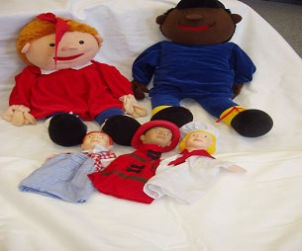

Survey sheets
There are two examples of survey sheets attached to this pack; these can be used very simply for children to indicate preferences and thoughts. They can be used for finding out specific information and are particularly useful for planning.
Children can indicate preferences with stickers, ticks or by circling the object or picture.
A group of line drawings for children to circle or mark with a sticker, depicting: hills, fire pit, animals, swings, beach, bike track, den, trees, rocks, pond, structures, mirrored wall, sensory garden and vegetable patch

Survey Sheet 1

Survey Sheet 2

