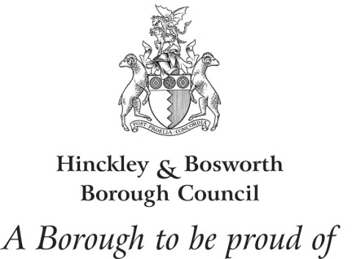
Market Bosworth Neighbourhood Plan
The Neighbourhood Planning (General) Regulations 2012 (Regulation 16)
Publication of Plan Proposal Consultation
Monday, 24 November 2014 to 17:00 on Friday, 9 January 2015
Response Form
Respondent Details
Name:
Address:
Telephone:
Email:
Organisation (if applicable):
Position (if applicable):

Your Representation on the Market Bosworth Neighbourhood Plan
Overall do you support the plan, would support the plan with some modifications, or oppose the plan? (please tick one answer)
Support Support with Modifications Oppose

Please indicate whether you wish to be informed of any decision by Hinckley and Bosworth Borough Council to either make/adopt the Neighbourhood Plan or refuse to make/adopt the Neighbourhood Plan.

Yes, please inform me of the decision

No, I do not wish to be informed of the decision

Please give details of your reasons for support/opposition
Paragraph number/policy reference | Comments/Suggested Modifications
(Continue on additional sheets if necessary)

Signature: | Date:

Data protection privacy notice
The personal data you have supplied to Hinckley & Bosworth Borough Council during this consultation period will be processed in accordance with the Data Protection Act 1998. Together with your comments, it will be used as part of the statutory plan making process and will be available for public inspection. Signatures, email addresses and telephone numbers will be removed before disclosure as a matter of course. We cannot provide anonymity or accept comments marked ‘private or confidential’ and comments that include offensive, racist, discriminatory, threatening and other non-relevant statements will be destroyed.

