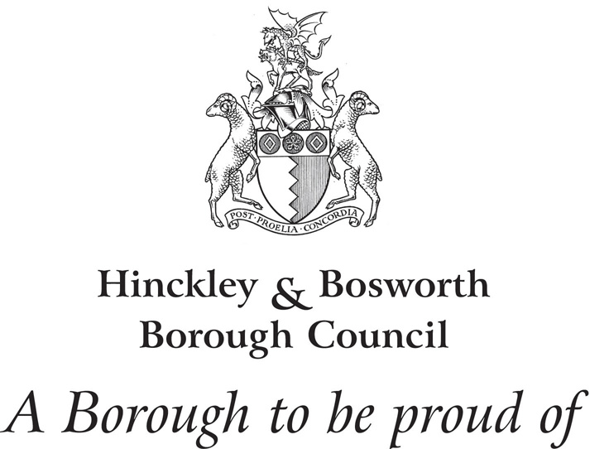
Site Allocations and Development Management Policies Development Plan Document
Main Modifications Consultation
Friday, 5 February 2016 – 5pm Friday, 18 March 2016
Response Form
GUIDANCE NOTES ON SHOULD BE READ BEFORE COMPLETING THIS FORM  ALL REPRESENTATIONS MUST BE RECEIVED BY:  5pm  Friday, 18 March 2016 | When completed, the form should be returned:  By post to:  The Planning Policy Team  Hinckley & Bosworth Borough Council  Hinckley Hub, Rugby Road  Hinckley, Leicestershire  LE10 0FR  By email to:  planningpolicy@hinckley-bosworth.gov.uk  This form can also be completed online at:  www.hinckley-bosworth.gov.uk/siteallocations
RESPONDENT DETAILS:
(If you have appointed an agent to act on your behalf please complete both personal and agent’s details)
 | PERSONAL DETAILS | AGENT’S DETAILS
*Customer Ref No:
Title:
First Name:
Last Name:
Job Title:
(if applicable)
Organisation:
(if applicable)
Address 1:
Address 2:
Address 3:
Address 4:
Postcode:
Telephone No:
E-mail Address:

Signature: | Date:

- To which Main Modification does your representation relate?
(Please complete a separate form for each representation)
Main Modification Number:

- Do you consider the Main Modification to be legally complaint?
Yes
No

- Do you consider the Main Modification to be ’sound’?
Yes
No

If you have answered No to Q3, please answer Q4, otherwise go to Q5

- If you consider the Main Modification to be unsound, please identify your reasons for this by ticking the appropriate box. The Main Modification is not:
Positively Prepared
Justified
Effective
Consistent with National Policy

- Please explain why you consider the Main Modification is not legally compliant or is unsound, being as precise as possible. If you have answered Yes to Q2 or Q3 and wish to support the legal compliance or soundness of the Main Modification, please use the box to set out your comments.
(Continue on additional sheets if necessary)

- If you consider that the Main Modification is not legally compliant or is unsound, please set out what change(s) you consider necessary to make it legally compliant or sound, having regards to your response to Q4 above. Please set out below in detail your suggested revised wording of any policy or text and explain why your suggested change will make the Main Modification legally compliant or sound. Please be as precise as possible.
(Continue on additional sheets if necessary)

Please note:
Your representations should cover succinctly all the information, evidence and supporting information necessary to justify your representation and any suggested change.
Representations should only relate to the Main Modifications. This consultation is not an opportunity to repeat or raise further representations about the published plan or seek changes to the plan. If the Inspector considers new issues or matters are raised as a result of these representations, he may decide to resume the hearings to enable these points to be discussed.

PLEASE ENSURE THAT YOU HAVE SIGNED AND DATED THE FRONT PAGE OF THIS FORM BEFORE SUBMISSION
Data protection privacy notice
The personal data you have supplied to Hinckley & Bosworth Borough Council during this consultation period will be processed in accordance with the Data Protection Act 1998. Together with your comments, it will be used as part of the statutory plan making process and will be available for public inspection. Signatures, email addresses and telephone numbers will be removed before disclosure as a matter of course. We cannot provide anonymity or accept comments marked ‘private or confidential’ and comments that include offensive, racist, discriminatory, threatening and other non relevant statements will be destroyed.

