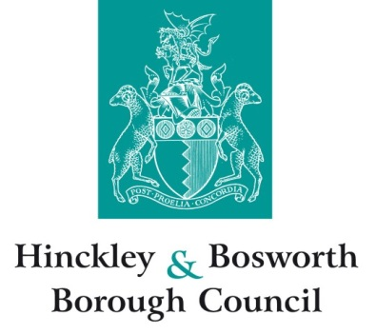

Appointment of new local auditor

The Local Audit and Accountability Act 2014 and the Local Audit (Appointing Person) Regulations 2015

As required by the Local Audit and Accountability Act 2014, the council gives notice of the appointment of Ernst & Young LLP to audit the accounts of Hinckley & Bosworth Borough Council for five years for the accounts from 2018/19 to 2022/23. This appointment is made under regulation 13 of the Local Audit (Appointing Person) Regulations 2015 and was approved by the Public Sector Audit Appointments (PSAA) Board at its meeting on 14 December 2017. Formal notification of the appointment was received from PSAA on 18 December 2017.

