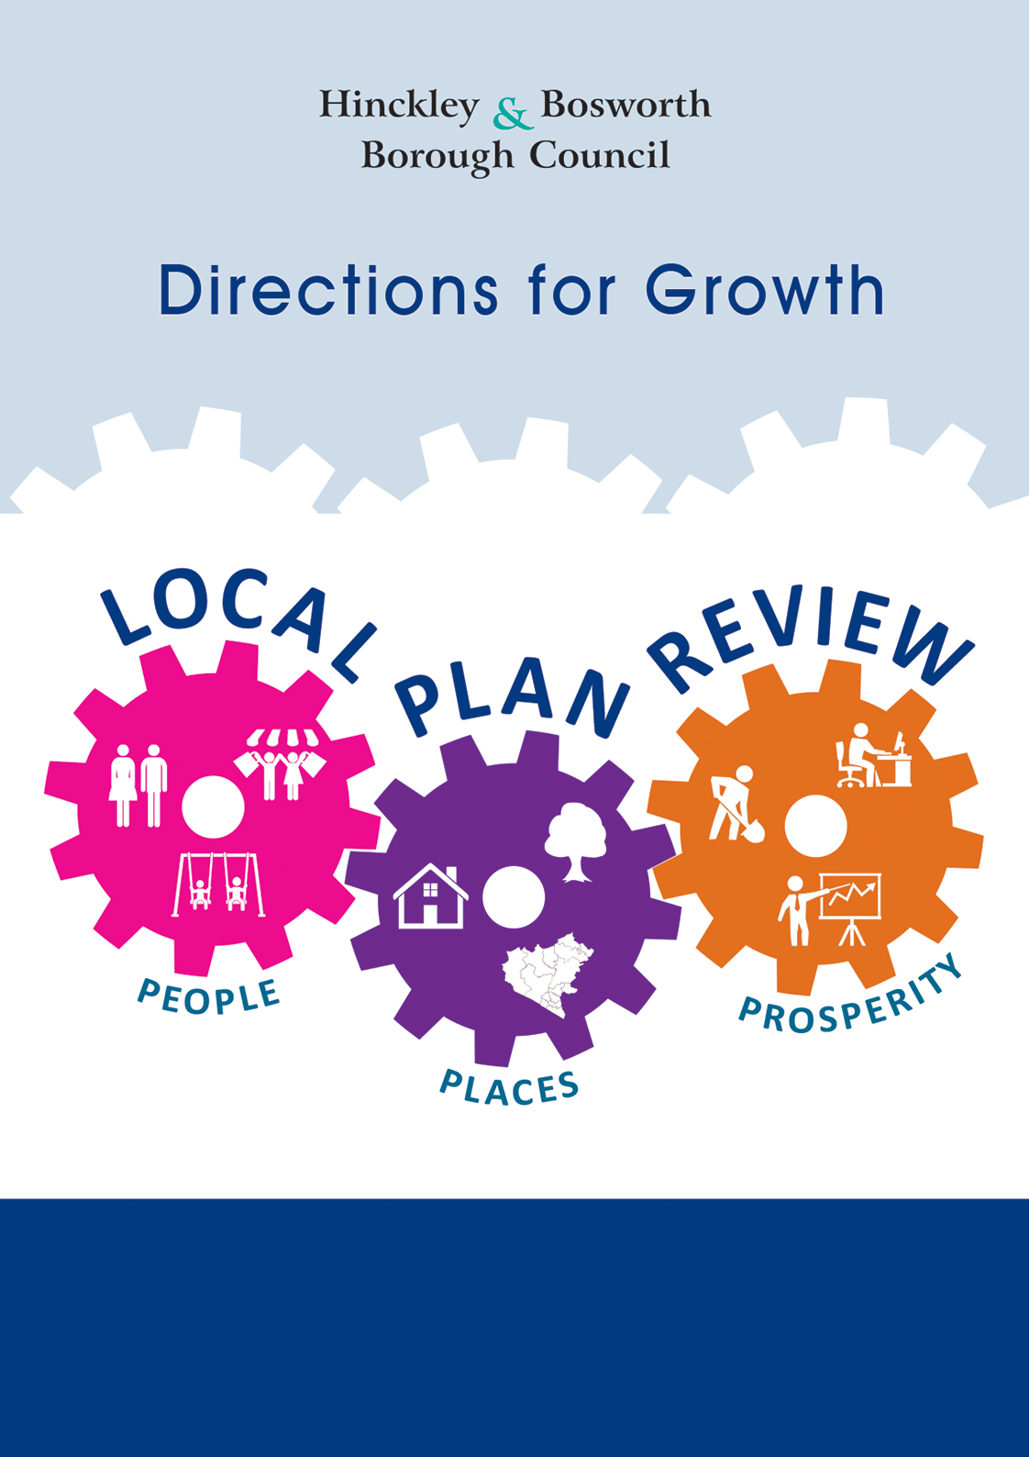
New Directions for Growth
Consultation response form January 2019

About this consultation

This consultation is open for 8 weeks from

Monday 7 January 2019 to 5pm Sunday 3 March 2019

The Council prefers to receive your consultation responses on-line,
however, you may also respond by email or post using the details below.

On-line (preferred) | completing our online consultation at www.hinckley-bosworth.gov.uk/localplanreview
Email | planningpolicy@hinckley-bosworth.gov.uk
Post | Planning Policy,  Hinckley & Bosworth Borough Council  Hinckley Hub,  Rugby Road  Hinckley, Leicestershire  LE10 0FR

Consultation responses, including for the Call for Sites, will be made public as part of subsequent stages of the Local Plan Review. Please clearly identify any information provided which is commercially sensitive and/or you would like to be kept confidential.
Your contact details

Name

Organisation
(if applicable)
Representing
(e.g. self or client)
Email Address

Postal Address

Telephone Number

New Directions for Growth Consultation Questions

Options outside of the urban area

Question 1
Do you consider the urban area of Hinckley, Burbage, Earl Shilton and Barwell suffers from transport and infrastructure challenges? If so please explain what you consider the issues to be.

Question 2
Should the authority explore other options for growth beyond the existing urban area? Do you support this and if so why.

Question 3
If you consider the authority should explore options for growth beyond the existing urban area, within which broad areas identified on map 3 should we focus on, and why?

Options for New Settlements

Question 4
A new settlement could address some of the housing and employment growth needs in the borough. Should the authority explore options for a new settlement?

Question 5
No land has so far been identified which could have the potential to accommodate a new settlement. If you think a new settlement is a good idea do you have any suggestions for where a new settlement could be located within the borough?

Question 6
Do you have any other comments/suggestions for how the borough can meet its housing and employment growth needs up to 2036?

