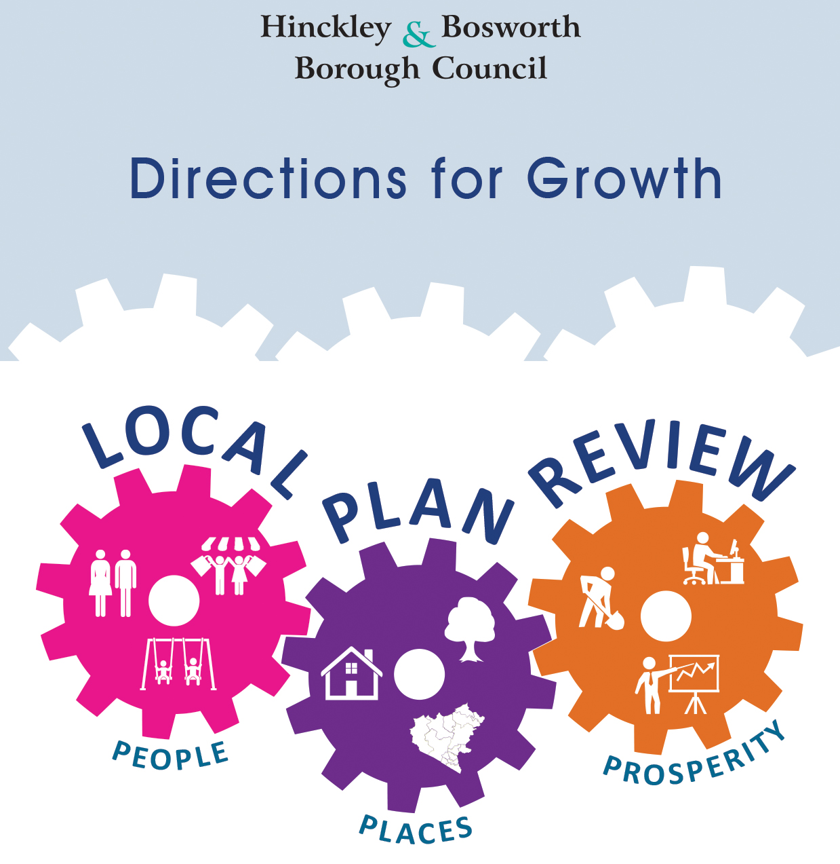

January 2019

New Directions for Growth Consultation

‘Call for Sites’ submission form

Call for Sites Submission
Please provide as much information as possible to ensure the Council can make a detailed assessment of the sites’ potential.

All sites submitted will be individually assessed by the Planning Policy team, and will be considered as part of the next review of the Strategic Housing and Economic Land Availability Assessment (SHELAA).
Please note the submission of a site DOES NOT guarantee that it will be allocated for development nor does it grant planning permission for any form of development.
Please note – if you have submitted a site as part of the 2016/2017 SHELAA call-for-sites, or as part of the Scope Issues and Options 2018 call-for-sites you do not need to submit the site to us again. All of the sites submitted to us previously will have been assessed in the 2017/18 SHELAA.
If you want to check whether your site has been submitted previously, please contact the Planning Policy team on planningpolicy@hinckley-bosworth.gov.uk
If you submitted a site/s in a previous call-for-sites, please ensure you fill in the section below which asks “Would you like the council to retain your site within the SHELAA for consideration in the Local Plan review?”
Information held by the Council is subject to the Freedom of Information Act, therefore please clearly identify any information provided which is commercially sensitive and/or you would like to be kept confidential.

Privacy notice

The personal data you have supplied to Hinckley & Bosworth Borough Council during this consultation period will be processed in accordance with Article 6(1)(e) of the General Data Protection Regulation and the Data Protection Act 2018. Together with your comments, it will be used as part of the statutory plan making process and will be available for public inspection. Signatures, email addresses and telephone numbers will be removed before disclosure as a matter of course. We cannot provide anonymity or accept comments marked ‘private or confidential’ and comments that include offensive, racist, discriminatory, threatening and other non-relevant statements will be destroyed. For more about how we use personal data, https://www.hinckley-bosworth.gov.uk/privacy (opens in a new window or tab).

How to Respond:

On-line | Completing the form online at www.hinckley-bosworth.gov.uk/localplanreview
Email | planningpolicy@hinckley-bosworth.gov.uk
Post | Planning Policy,  Hinckley & Bosworth Borough Council  Hinckley Hub,  Rugby Road  Hinckley, Leicestershire  LE10 0FR

Your contact details
Name and company (if relevant):
On behalf of (if relevant):
Address:
Telephone number:
Email address:
 | ☐Planning Consultant | ☐Developer
 | ☐Registered social landlord | ☐Other (please provide details below)
If there is more than one landowner, please list the names and addresses of all other landowners involved with the site:

Site details
Site Address:
Site reference (if known):
Would you like the council to retain your site within the SHELAA for consideration in the Local Plan review?  If “No”, you do not need to complete the remainder of this proforma. | ☐Yes  SHELAA  Ref (if known): | ☐No
Site size (Ha):
Current site use(s):
Adjacent uses:
Please indicate which potential use(s) for the site you would consider acceptable: | ☐Housing  ☐Housing for older people  ☐Offices  ☐Warehouses  ☐Retail  ☐Leisure  ☐Open space  ☐Gypsy, Traveller or Travelling Showpeople site  ☐Self-build plots  ☐Other (please specify)

Site constraints. Does the site have any of the following?
Contaminated Land Constraints (e.g. hazardous/polluted ground conditions, previous hazardous land uses, unstable/contaminated structures):

Environmental Constraints: (e.g. any negative effects on the local landscape, e.g. loss of mature woodland, loss of locally used open space or access to open space, etc):

Topographical Constraints (e.g. site slopes, flood risk, varying sites levels, etc):

Accessibility Constraints (e.g. any problems or limitations related to the access of the site and any infrastructure requirements):

Planning Policy Constraints (e.g. based on current adopted policy, designations or protected areas e.g. SSSIs, Conservation Areas, Local Nature Reserves):

Ownership Constraints (e.g. details of land ownership and any legal or ownership issues including multiple ownership, tenancies, ransom strips or operational requirements of landowners):

Opportunities
Is there market interest in the site? | ☐ Yes |  | ☐ No
If “Yes”, which is the most appropriate level of interest? | ☐ High | ☐ Medium |  | ☐ Low
What would be the likely time frame for development? | ☐ 0 – 5 years | ☐ 6 – 10 years |  | ☐ 11 years plus
If known, would the site involve a single developer or several developers?

What would be the estimated floor area (sqm) of proposed uses for the site?

What would be the estimated number of proposed dwellings for the site and at what density?

Additional information:

Date: ………………………………………………

