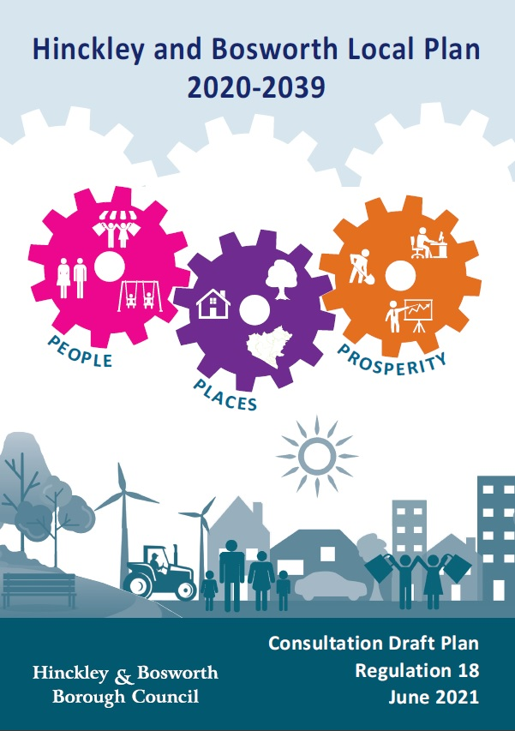
Draft Local Plan Consultation
Wednesday 30 June 2021 to Friday 27 August 2021

Comments Form

About this consultation

This consultation is open for 8 weeks between

Wednesday 30 June 2021 to Friday 27 August 2021

The Council prefers to receive your consultation responses on-line,
however, you may also respond by email or post using the details below.

Online (preferred):
completing our online consultation at www.hinckley-bosworth.gov.uk/localplanreview

Email: planningpolicy@hinckley-bosworth.gov.uk

Post:
Planning Policy
Hinckley & Bosworth Borough Council
Hinckley Hub
Rugby Road
Hinckley
Leicestershire
LE10 0FR

Consultation responses will be made public as part of subsequent stages of the Local Plan Review.

Privacy statement
The personal data you have supplied to Hinckley & Bosworth Borough Council during this consultation period will be processed in accordance with Article 6(1)(e) of the General Data Protection Regulation and the Data Protection Act 2018. Article 9(2)(c) of the General Data Protection Regulation and the Data Protection Act 2018 also applies, as we will be collecting Special Category Data to help support our Local Plan consultation process. This data will not be shared with any third parties and will be anonymised. Together with your comments, it will be used as part of the statutory plan making process and will be available for public inspection. Signatures, email addresses and telephone numbers will be removed before disclosure as a matter of course. We cannot provide anonymity or accept comments marked ‘private or confidential’ and comments that include offensive, racist, discriminatory, threatening and other non-relevant statements will be destroyed. For more about how we use personal data, visit www.hinckley-bosworth.gov.uk/privacy

Draft Local Plan – Consultation Response Form

Your contact details

Title
First Name
Surname
Organisation
(if applicable)
Representing
(if applicable)
Postal Address
Email Address
Telephone Number

Draft Local Plan Consultation Questions

Question 1:
I wish to make a general comment on the plan or a comment not related to the specific questions set out in the document.
Question 2:
Do you have any comments on the Spatial Portrait of the Borough?
Question 3:
Do you agree with the Plan Vision? If not, what changes do you suggest?
Question 4:
Do you agree with the Spatial objectives? If not, what changes do you suggest?
Question 5:
Do you support the preferred strategy for growth set out above for the local plan? If not, what do you consider would be a reasonable alternative strategy for growth?
Question 6:
We consider a new settlement will be required to help meet future growth needs in the borough. How can this best be reflected in policy?
Question 7:
Do you agree with the approach to mitigating and adapting to climate change?
Question 8:
Once site allocations are set out in the next draft of the Local Plan the policy CC02 will include a list of those site allocations which will need to address recommendations made in the Borough Council’s Strategic Flood Risk Assessment Level 2. Do you agree with this approach?
Question 9:
Do you support the overall proposed strategy for high quality design in the borough? Are there any other issues the policy should address?
Question 10a:
Should the Active Design and Travel Policy apply only to new residential development or should other development types be included?
Question 10b:
Is the threshold of 10 or more residential dwellings appropriate?
Question 11:
Should the housing mix policy apply to all residential developments or only to developments of 10 or more dwellings?
Question 12:
Do you agree that the nationally described space standards should apply to all new dwellings?
Question 13:
How can the emerging national design code guidance on density be better incorporated into the policy on housing density?
Question 14:
Do you agree with the policy approach to Self and Custom build housing?
Question 15a:
Do you have any comments on the criteria based approach to Gypsy, Traveller and Travelling Showpeople accommodation set out in the policy?
Question 15b:
If the accommodation assessment identifies an evidenced need to allocate land for Gypsy, Traveller and Travelling Showpeople accommodation should this be through the local plan or a separate Development Plan Document?
Question 16a:
Do you have any comments on the broad approach to securing affordable housing?
Question 16b:
Where 100% affordable housing schemes are proposed and supported with Affordable Homes Grant from Homes England should they be exempt from providing other planning contributions as explained in the supporting text to the policy?
Question 17:
How can the Local Plan best deliver the necessary employment land and premises required to meet its identified needs?
Question 18:
Should some key employment areas/premises that are of particular significance to Hinckley & Bosworth’s portfolio of employment areas be afforded additional protection over and above category A areas? If so, should this include all category A areas, some category A areas, or a mixture of category A & B areas? What extra evidence would be needed to warrant this special policy designation?
Question 19:
Do you have any comments on the planning for Strategic Distribution developments in Hinckley and Bosworth, and how local policy could be formulated?
Question 20:
Taking into account the recent creation of Class E planning uses and the implications for employment uses and sites/premises, what changes if any do you think should be made to the Economic Prosperity section and policies?
Question 21a:
Should policy define the expected extent of search for sequentially preferable sites? As a minimum, the nearest Town, District or Local Centre should be assessed. Further options could include always assessing Hinckley Town Centre, assessing all Town, District and Local Centres in the Borough, using development size thresholds or using catchment area distances, which could also include defined centres of neighbouring local authorities.
Question 21b:
Should permissions for E use in or edge of centre be conditioned to exclude light industry (the former B1c use)?
Question 21c:
Where retail use is proposed in-centre, should it be conditioned to prevent Change of Use to other E class uses?
Question 21d:
Where particular non-retail E class uses can pass the sequential test and be permitted because they require large site footprints difficult to accommodate in-centre, should they be subject to conditions restricting change of use to retail?
Question 22a:
What should the role of Policy TDC02 be if the Government introduces a permitted development right to change Class E use to Class C3 (residential)?
Question 22b:
Should the borough consider the use of an Article IV Direction to help protect any particularly valuable Town Centre uses?
Question 22c:
Is there a role for Primary and/or Secondary Shopping Frontages to help with the definition of key locations at ground floor level in Policy TDC02? If so, should primary and secondary frontages be defined for the District Centres (as recommended in the Town and District Centres Study 2017) or any other centre?
Question 23:
Could the measure of “over-proliferation” of facilities be improved and does the measure need to be individually tailored to suit centres in different levels of the centre hierarchy?
Question 24:
Are the criteria for safeguarding against the loss of public houses in urban and rural areas reasonable and proportionate and are there any other criteria the Borough Council should include to safeguard against the loss of public houses?
Question 25:
Do you have any comments on the approach to Heritage and Conservation?
Question 26:
Do you support the approach to green wedges set out in the policy?
Question 27:
Do you agree with the ‘major developments’ threshold set out in the biodiversity policy or should a different threshold be applied for the additional biodiversity gains measures?
Question 28:
Do you have any comments on the policy for development within the countryside?
Question 29:
Do you agree with the approach to highways and transportation set out in policy HT01?
Question 30:
Are there any other locations or criteria you think would be acceptable to support the delivery of HGV parking facilities?
Question 31:
Should the policy set different electric vehicle charging infrastructure requirements for different types of non-residential uses, for example rapid charging points at commercial/retail developments or more charging points at long stay locations such as employment sites?
Question 32:
Do you agree with the approach of seeking to safeguard land along the A5 corridor? Are there any constraints or issues which could preclude the Council, in conjunction with the A5 Partnership, from safeguarding this land?
Question 33:
Should the policy be amended to reflect emerging Government proposals for infrastructure funding and planning gain set out in the Planning White Paper?

Equalities Information

- What is your age? [Please tick one box which applies]
Under 16
16-25
26-35
36-45
46-55
56-65
Over 65
Prefer not to say

- Do you have a long term illness or disability?
Yes
No
Prefer not to say

- If yes, please specify the type of impairment(s). [Please tick the boxes which applies]
Physical or mobility impairment (including arthritis, cerebral palsy and using a wheelchair)
Sensory impairment (including hearing, sight and speech impairments)
Learning impairment (including dyslexia and autism)
Mental health (including anxiety, bipolar disorder and depression)
Communication impairment (including speech impairment)
Long term illness (including cancer, diabetes, HIV and multiple sclerosis)
Other Please specify………………………….
Prefer not to say

- How do you identify your gender? [Please tick one box which applies]
Male
Female
Prefer to self-describe …………………
Prefer not to say

- Do you identify as the same gender you were assumed to be at birth?
Yes
No
Prefer not to say

- What is your ethnicity? [Please tick one box which applies]
White – British / English / Northern Irish / Scottish or Welsh White - Irish
White – Gypsy or Irish Traveller
White – Any other White background
Please specify……………………………….
Asian/Asian British – Indian Asian/Asian British – Pakistani
Asian/Asian British – Bangladeshi Asian/Asian British – Chinese
Asian/Asian British - Any other Asian background
Please specify………………………………………………
Black/African/Caribbean/Black British – African
Black/African/Caribbean/Black British – Caribbean
Black/African/Caribbean/Black British – Any other Black/African/Caribbean background Please specify…….
Mixed/Multiple ethnic groups – White and Black Caribbean
Mixed/Multiple ethnic groups – White and Black African
Mixed/Multiple ethnic groups – White and Asian
Mixed/Multiple ethnic groups – Any other Mixed/Multiple ethnic background. Please specify……………
Other ethnic group: Arab
Other ethnic group: Any other ethnic group
Please specify……………………………………………..
Prefer not to say

- What is your sexual orientation? [Please tick one box which applies]
Heterosexual or straight
Gay or lesbian
Bisexual
Prefer to self-describe ……………
Prefer not to say
I don’t know

- What is your religion or belief? [Please tick one box which applies]
Christianity
Hinduism
Judaism
Islam
Buddhism
Sikhism
I have no religion or belief
Other - Please specify…………
Prefer not to say

- Are you married or in a civil partnership? [Please tick one box which applies].
Married
Civil Partnership
Prefer to self-describe……………
Single (Not married or in civil partnership)
Prefer not to say

- Have you been pregnant, on maternity leave or breastfeeding within the last six months? [Please tick one box which applies].
Yes
No
Prefer not to say

About The Local Plan

- Overall, has the Local Plan adequately considered principles of equality and inclusion?
Strongly Agree
Agree
Neutral
Disagree
Strongly Disagree

- Overall, is the Local Plan compliant with the Public Sector Equality Duty?
Strongly Agree
Agree
Neutral
Disagree
Strongly Disagree

- Overall, does the Local Plan reflect the make-up of the Hinckley & Bosworth community?
Strongly Agree
Agree
Neutral
Disagree
Strongly Disagree

- Overall, have Hinckley & Bosworth Borough Council accommodated or allowed provision for reasonable person specific requests? (Such as accessibility requests relating to disability or language).
Strongly Agree
Agree
Neutral
Disagree
Strongly Disagree

Thank you for your response to the equalities questions.

