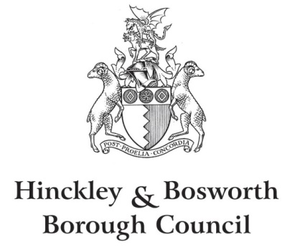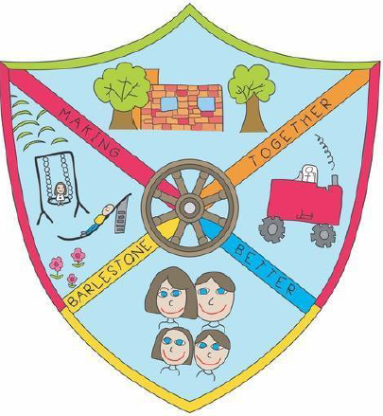

Barlestone Neighbourhood Plan

The Neighbourhood Planning (General) Regulations 2012 (Regulation 16)
Publication of Plan Proposal Consultation

Wednesday, 15th September 2021 to 17.00 Wednesday, 27th October 2021

Response Form

How to respond:
- Complete our planning policy contact form
- Send a letter to the planning policy team
- Download, complete and return this Barlestone Regulation 16 response form
- Please return to the Hinckley Hub or electronically using our planning policy contact form
Respondent Details
Detail | Write Details
Name:
Address:
Telephone:
Email:
Organisation (if applicable):
Position (if applicable):

Your Representation on the Barlestone Neighbourhood Plan

Overall do you support the plan, would support the plan with some modifications, or oppose the plan? (please tick one answer)

Support Support with Modifications Oppose

Please indicate whether you wish to be informed of any decision by Hinckley and Bosworth Borough Council to either make/adopt the Neighbourhood Plan or refuse to make/adopt the Neighbourhood Plan.

Yes, please inform me of the decision

No, I do not wish to be informed of the decision

Please give details of your reasons for support/opposition
Paragraph number/policy reference | Comments/Suggested Modifications
Continue on additional sheets if necessary

Signature: Date:

Privacy notice
All comments will be made available, and identifiable by name and organisation (where applicable) to the appointed examiner, Local Planning Authority, and Barlestone Parish Council. Please note that any personal information will be processed by the council in line with the Article 6(1)(e) of the General Data Protection Regulation and the Data Protection Act 2018

