
2026 Air Quality Annual Status Report (ASR)
In fulfilment of Part IV of the Environment Act 1995 Local Air Quality Management, as amended by the Environment Act 2021
Date: June 2026

Information | Hinckley and Bosworth Borough Council Details
Local Authority Officer | Giles Rawdon
Department | Environmental Health (Environmental Protection)
Address | Hinckley & Bosworth Borough Council  Environmental Health  Hinckley Hub  Rugby Road  Hinckley  Leicestershire  LE10 0FR
Telephone | 01455 255684
E-mail | giles.rawdon@hinckley-bosworth.gov.uk
Report Reference Number | ASR_HBBC_2026_v1
Date | June 2026

Local Responsibilities and Commitment
This ASR was prepared by the Environmental Protection department of Hinckley & Bosworth Borough Council with the support and agreement of the following officers and departments:
Caroline Roffey, Head of Street Scene Services, Street Scene Services, HBBC
Chris Brown, Assistant Director Planning and Regeneration, HBBC
Helena Searle, Carbon Reduction and Climate Change Officer, Private Sector Housing, HBBC
Natalie Howden, Strategic Lead- Wider Determinants of Health, Public Health Leicestershire County Council
Karen Mason, Sports Development Manager, Cultural Services, HBBC
Donna Hall, Transport Strategy Officer, Transport Strategy & Policy, LCC
This ASR has been approved by:
Simon Smith, Team Leader- Environmental Protection, HBBC
This ASR has been signed off by a Director of Public Health.
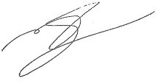
Mike Sandys
Director of Public Health, Communities, Law and Governance

If you have any comments on this ASR please send them to If you have any comments on this ASR please send them to Giles Rawdon at:
Hinckley & Bosworth Borough Council
Environmental Health
Hinckley Hub
Rugby Road
Hinckley
Leicestershire
LE10 0FR
01455 255684
giles.rawdon@hinckley-bosworth.gov.uk

Executive Summary: Air Quality in Our Area
Air Quality in the Borough of Hinckley and Bosworth
Breathing in polluted air affects our health and costs the NHS and our society billions of pounds each year. Air pollution is recognised as a contributing factor in the onset of heart disease and cancer and can cause a range of health impacts, including effects on lung function, exacerbation of asthma, increases in hospital admissions and mortality.
Air pollution particularly affects the most vulnerable in society, children, the elderly, and those with existing heart and lung conditions. Low-income communities are also disproportionately impacted by poor air quality, exacerbating health and social inequalities.
Table ES 1 provides a brief explanation of the key pollutants relevant to Local Air Quality Management and the kind of activities they might arise from.
Table ES 1 - Description of Key Pollutants
Pollutant | Description
Nitrogen Dioxide (NO₂) | Nitrogen dioxide is a gas which is generally emitted from high-temperature combustion processes such as road transport or energy generation.
Sulphur Dioxide (SO₂) | Sulphur dioxide (SO₂) is a corrosive gas which is predominantly produced from the combustion of coal or crude oil.
Particulate Matter  (PM₁₀ and PM_{2.5}) | Particulate matter is everything in the air that is not a gas.  Particles can come from natural sources such as pollen, as well as human made sources such as smoke from fires, emissions from industry and dust from tyres and brakes.  PM₁₀ refers to particles under 10 micrometres. Fine particulate matter or PM_{2.5} are particles under 2.5 micrometres.

The Annual Status Report did not identify any exceedances of the Air Quality Objectives based on the assessment criteria in Local Air Quality Management Technical Guidance LAQM (TG22). In line with national trends levels of Nitrogen Dioxide (NO₂) continue a steady decline as can be seen in table A4.

The principal pollutant of concern in the borough is NO₂ from the road network. NO₂ is released into the atmosphere when fuels are burned (for example, petrol or diesel in a car engine or natural gas in a domestic central heating boiler or power station).

Hinckley and Bosworth Borough Council (HBBC) had 14 diffusion tube sites (now 16 as of January 2026) around the Borough that measure levels of NO₂. These sites are located in areas more likely to be affected by poorer air quality usually due to their proximity to busy roads. The sites allow HBBC to monitor air quality in those areas and take any necessary action based upon the results. Further details of these sites and the results are provided in Appendix A. The location of each tube is shown in Appendix D. The QA/QC data for the sites are given in Appendix C.

Overall Air Quality in the Borough is good when compared to the air quality objective value. Measured levels of NO₂ within the borough in 2025 continue to show a decrease when compared to pre-pandemic levels and most sites measured less NO₂ than in 2020.

The monitoring location on Shaw Lane in Markfield (sites 10, 12 and 14) again measured levels of NO₂ lower than in previous years demonstrating the improvement to traffic management following works to the Flying Horse roundabout.

Actions to Improve Air Quality
Whilst air quality has improved significantly in recent decades, there are some areas where local action is needed to protect people and the environment from the effects of air pollution.
Environmental Permitting
HBBC is the regulatory authority for Part A2 and B industrial installations under the Environmental Permitting (England and Wales) Regulations 2016. There are a number of industrial sites in the borough which require an Environmental Permit to operate. This includes brickworks, quarries, petrol stations, some incinerators, dry cleaners and paint-shops amongst other facilities. Each installation is inspected by Environmental Health (Environmental Protection) to monitor compliance with the Environmental Permit for the site and ensure that emissions to atmosphere are adequately controlled. The frequency of inspection is determined by a risk rating system. As Best Available Techniques (BAT) improve with new technological advances improvements to air quality are gained through this regime.

The latest register of Permitted Processes in the Borough can be found at: http://www.hinckley-bosworth.gov.uk/downloads/file/871/environmental_permitting_public register updated_24_february_2016

Development Control
Development Control provides an opportunity for agencies, and the public, to comment upon air quality impacts of proposed developments.

The latest National Planning Policy Framework (NPPF), issued by the Ministry of Housing, Communities and Local Government in 2024, sets out the Government’s planning policies for England and how these are to be expected to be applied. The NPPF must be taken into account in the preparation of local and neighbourhood plans, and is to be a material consideration in planning decisions. The NPPF advises that planning policies and decisions should contribute to and enhance the natural and local environment by:

“preventing new and existing development from contributing to, being put at unacceptable risk from, or being adversely affected by, unacceptable levels of soil, air, water or noise pollution or land instability. Development should, wherever possible, help to improve local environmental conditions such as air and water quality, taking into account relevant information such as river basin management plans”.

Paragraph 199 advises that:
“Planning policies and decisions should sustain and contribute towards compliance with relevant limit values or national objectives for pollutants, taking into account the presence of Air Quality Management Areas and Clean Air Zones, and the cumulative impacts from individual sites in local areas. Opportunities to improve air quality or mitigate impacts should be identified, such as through traffic and travel management, and green infrastructure provision and enhancement. So far as possible these opportunities should be considered at the plan-making stage, to ensure a strategic approach and limit the need for issues to be reconsidered when determining individual applications”.

Hinckley and Bosworth Borough Council’s Site Allocations and Development Management Policies (SADMP) Development Plan was adopted in 2016. The plan requires that adverse impacts from air pollution will be prevented by ensuring that development proposals demonstrate that they will not contribute to poor air quality.

The SADMP is currently being updated with work underway on a new Local Plan. This included a consultation of the Regulation 18 draft Local Plan in July-September 2024 and a further Regulation 18 draft Local Plan in October-November 2025, then Regulation 19 stage in summer 2026 and be submitted to the Secretary of State by the end of December 2026.”

Leicestershire Air Quality Forum
Environmental Health (Environmental Protection) attends the Leicestershire Air Quality Forum - a forum comprising professionals involved in Air Quality to discuss issues and disseminate best practice. The forum is also regularly attended by other Leicestershire district and county council colleagues including Public Health and Highways.

Leicestershire Air Quality and Health Partnership
Environmental Health (Environmental Protection) also attend the Leicestershire Air Quality and Health Partnership. The Partnership was established by Leicestershire County Council in May 2019 to facilitate joint working across organisational boundaries, initially informed by recommendations from the Air Quality and Health Joint Strategic Needs Assessment (2019).
The Partnership brings together representatives from Leicestershire County Council – including Public Health, Research and Insight, Communications, and Environment and Transport – alongside District and Borough Councils with statutory responsibilities for air quality, and NHS Leicester, Leicestershire and Rutland.

Building on this earlier work, a refreshed Action Plan has been developed through the Leicestershire Health Needs Assessment: Air Quality and Health (2024). This updated assessment sets the current priorities for collaborative action to improve air quality and health outcomes across the County.

Transport - Planning and Policy Context
National Highways Transport Policy
National Highways, formerly called Highways England and Highway Agency, is a government owned company responsible for managing and improving the Strategic Road Network (SRN) i.e. Motorways and major A roads in England, including the M1, M69 and A5. As such, actions taken on these roads will be undertaken by them.

In July 2021 National Highways produced a progress update on the Air Quality on England’s SRN, which highlights the need to improve local air quality, exploring behavioural change measures on or close to the SRN.

National Highways Air Quality - Annual Evaluation report 2024, (published in July 2025), provides a summary of the latest compliance status for sections of the SRN that have been assessed for air quality by National Highways up to the end of 2024. This report also provides an update on the progress of measures that have been implemented to improve air quality on these links during this time. The report, which shows an improving picture of air quality alongside their network, is available on National Highways website at: https://nationalhighways.co.uk/our-work/environment/communities/air-quality/air-quality-library/

Road Investment Strategy 3 (RIS3) is now published, and is available on the Government’s website at: https://www.gov.uk/government/publications/road-investment-strategy-3-ris3-2026-to-2031

The A5 Gibbet Hill and A5 Dodwells to Longshoot (and A5/M42 junction outside of Leicestershire) are listed as RIS4 Pipeline development schemes, albeit funding for delivery is not confirmed at this time.

Leicestershire County Council’s Strategic Plan
Leicestershire County Council’s Strategic Plan (refresh 2024-2026) states that ‘reducing our carbon footprint supports both our aims to tackle climate change and to improve health outcomes’. The ‘Clean and Green’ strategic outcome includes:

- People act now to tackle climate change
- Nature and the local environment are valued, protected, and enhanced
- Resources are used in an environmentally sustainable way
- The economy and infrastructure are low carbon and environmentally friendly

The Strategic Plan notes that ‘we are confident that through actions such as enabling sustainable transport, promoting business action on climate change, and ensuring infrastructure developments are low or zero carbon, we can strike the right balance between ‘green and growth’’.

It also notes that ‘The County Council has various levels of control and influence in protecting the environment and addressing climate change. It is responsible for managing the environmental impacts of its own activities (e.g., heating and powering offices, using vehicles, and generating waste) and is able to help minimise the impacts of residents and businesses (e.g., by enabling and promoting sustainable transport, managing household waste in an environmentally sustainable way). Where resources allow, it can also try to influence wider action by working with partners and lobbying Government. We will seek to tackle climate change by embedding environmental sustainability into everything we do. We will minimise the environmental impact of our activities and use our influence in areas such as transport, planning, economic development, and community engagement to protect the environment’.

Leicestershire County Council’s Local Transport Plan
Leicestershire’s Local Transport Plan (LTP) Core Document 2025-2040, which was published in 2024, recognises that road-based travel is a key contributor to poor air quality which undermines the health of our communities. Air quality levels are recognised as a key indicator for monitoring our success in protecting the environment.

Protecting the environment is one of the core themes of LTP4, with core policy 3 – enabling travel choice – aiming to facilitate an integrated transport network to enable travel choices which meet users' needs and requirements whilst reducing carbon production, lowering emissions and provide benefit to the environment.

In addition, Leicestershire County Council also aims to improve the environment and reduce carbon emissions through a range of documents, including its Environment Strategy and Action Plan and the Environment and Transport Departmental Business Plan.

Air quality is recognised as a key environmental issue and there is an emphasis on using evidence. Leicestershire County Council’s suite of transport models can be used to assess air quality, taking account of factors such as growth. As the Local Highway Authority (LHA), the County Council:

- Can provide District/Borough councils with access to transport modelling services to enable them to assess the potential air quality and wider environmental impacts of possible Local Plan spatial strategies.
- Can help District/Borough councils identify and develop mitigation methods where pollution is attributable to the local road network.
- Is responsible for the safe and efficient movement of traffic on the road network.
- Sets out, through its Network Management Plan (NMP), a number of options available to tackle air quality, including maintaining and managing the road network so that it operates as efficiently and effectively as possible, reducing the need to travel by car, encouraging the use of sustainable transport, influencing how people travel, introducing improvements to tackle congestion.
- Promote walking, cycling and use of public transport. For example, in collaboration with Leicester City Council, it has implemented the ‘Choose How You Move’ programme, opening opportunities for travel to employment, education and training by active travel.

Sustainable Transport
Cycling and Walking Strategy
Leicestershire County Council adopted a new Cycling and Walking Strategy (CaWS) in July 2021. This set out its approach to help deliver the Government’s vision for cycling and walking (as set out in its ‘Gear Change’ cycling and walking plan for England) to help improve air quality, combat climate change, improve health and wellbeing, address inequalities, and tackle congestion on our roads.

The vision for the Leicestershire CaWS is ‘For Leicestershire to become a county where walking and cycling are safe, accessible, and obvious choices for short journeys, and a natural part of longer journeys, helping to deliver healthier, greener communities’.

As part of this Strategy, 10-year Local Cycling and Walking Infrastructure Plans (LCWIPs) have been/are being developed for towns and the urban areas surrounding Leicester City, setting out prioritised cycling and walking networks for improvement and investment to facilitate modal shift to active travel, helping deliver improved air quality in the area.

As part of the County Council’s LCWIP development programme for market towns; Hinckley and the surrounding area will be included. This will build on and update the work previously completed in the Hinckley Area Project. The LCWIP will enable better connectivity to key employment sites such as MIRA technological park and other sites, such as Hinckley Railway Station, which can be access by sustainable transport modes.

Passenger Transport
Leicestershire County Council recognises the very important role that buses and other passenger transport services have to play in keeping people and places connected, especially in a largely rural county such as Leicestershire. Use of such services rather than private car travel also helps reduce congestion, improves air quality in our towns, and limits carbon emissions.

The Leicestershire Bus Service Improvement Plan (BSIP) sets out ambitions to help deliver the Government National Bus Strategy, and its main aim to increase overall bus journeys in England. The delivery vehicle for the Leicestershire BSIP vision is an Enhanced Partnership (EP), in which the County Council work in partnership with all bus operators in the county and other interested parties, such as rail service operators, to improve bus and demand responsive transport (DRT) passenger transport services helping to increase patronage and reducing car use.

Leicestershire FoxConnect DRT is an on-demand service operating in several areas of Leicestershire, including Hinckley and Bosworth district and neighbouring Blaby district and Northwest Leicester district. Users can choose exactly where they want to be picked up and dropped off in the DRT zones, including Hinckley rail station for onward travel, providing a convenient and flexible way to travel at a time that suits people’s needs, helping to reduce single occupancy car travel in the district, improving air quality and limiting carbon emissions.

Connecting bus and DRT services to rail stations, in addition to active travel, allows for longer journeys to be made on rail services which are a sustainable travel mode that creates opportunities for people to reduce car use for those longer journeys helping further reduce impacts on air quality and carbon emissions.

Electric Vehicles

The government is committed to the switch to Electric Vehicles (EV) and investing in EV infrastructure; it will be a major contributor to net zero goals and improve the country’s air quality.

Whilst the delivery of EV charging infrastructure is not a legal requirement for local authorities, Government expects upper tier local authorities, such as Leicestershire County Council, to play a part in expanding the network of public chargepoints, addressing gaps in provision currently being provided by the private sector and supporting those with limited access to off-street parking. In September 2024, Leicestershire County Council approved its Leicestershire Electric Vehicle Charging Strategy (EVCS).

Leicestershire County Council will work closely with Hinckley and Bosworth to support ChargePoint planning and delivery, sharing resources and ensuring a coordinated and coherent approach. The roll out of EV infrastructure will encourage the uptake of EVs, therefore improving air quality and reducing pollutants being emitted across the road network.

Network Management Plan (NMP)
Leicestershire County Council published its Network Management Plan (NMP) in 2020. This document describes how it meets the network management duty and manages demand, encourages sustainable travel and manages traffic to reduce congestion and keep traffic moving to improve air quality.

The NMP sets out the activities carried out by the County Council and its partners, which can make a significant contribution to improving air quality. This includes maintaining and managing the road network, so that it operates as efficiently and effectively as possible, reducing the need to travel by car, encouraging the use of sustainable transport, influencing how people travel and introducing improvements to tackle congestion.

The NMP also highlights the actions developed in the Leicestershire Air Quality and Health Joint Action Plan (2024-28), which ensures that parties work together to develop their approach to addressing air quality, and that all necessary measures to address air pollution in their local areas are included.

Key growth corridor schemes, such as the A50/A511 Growth Corridor Scheme, will help to improve congestions and traffic flow, supporting growth in the area and improving air quality for residents.

The Watling Street Bridge on the A5, is frequently hit by HGV’s causing delays and congestion. Although not a sustained air quality issue in itself, the diversions through Hinckley impact on air quality. Current proposals to improve the road and bridge will help traffic flows along the A5, reduce HGV diversions, and improve air quality.

In September 2025 the Cabinet considered a report on an A5 Concept Link, a potential road link to connect the A5 and A47 in Hinckley. The report sought approval to undertake engagement activities to help develop the concept and ascertain its potential for delivery. Uncertainty regarding the programme of improvements to be implemented by National Highways, and the possibility of new land use developments nearby, led officers to develop a potential route to address the existing and future issues in this location. If taken forward in the future, the link could be a key transport measure that could help to enable the substantial amount of proposed growth in the Local Plan to be delivered in a sustainable manner in accordance with the National Planning Policy Framework. The report noted that engagement with Hinckley and Bosworth Borough Council would enable the A5 Concept Link to be used to support the progress of the Hinckley and Bosworth Local Plan and assist in discussions with the developers of the nearby sites.

Net Zero Leicestershire
In 2019, Leicestershire County Council declared a Climate Emergency, and followed this with a commitment to work with others across Leicestershire to achieve net zero by 2035 for its own operations and to reach the target of achieving net zero across the county by 2050, to align with government targets.

To facilitate this, Leicestershire County Council developed a range of environmental policies and reports, including a Net Zero Strategy and Action Plan, which sets out the approach to delivering the council’s ambitions, including working with partners and other public bodies across the county and region to deliver ambitious goals to reduce carbon and other greenhouse gas emissions. Actions to reduce these emissions will, in many or most cases, also help to reduce other air pollutants.

Climate Change
Hinckley and Bosworth Borough Council Carbon Management Plan
On 16 July 2019, Hinckley & Bosworth Borough Council (HBBC) declared a 'climate emergency'. Councilors pledged to take local action to contribute to national carbon neutral targets through the development of practices and policies, with an aim to being carbon neutral in the borough of Hinckley and Bosworth by 2030. Additionally, HBBC also declared a ‘biodiversity emergency’ in July 2023. Following this, the Climate Change and Biodiversity Strategy 2024-2028 was implemented. An accompanying action plan has also been created to monitor and report climate change delivery. This work has been achieved through a cross-collaboration approach within the council through the implementation of task and finish groups, these were revised in 2025 as:
- Corporate services,
- Buildings and land use,
- Community,
- Food,
- Planning.
In line with the strategy and targets, HBBC have taken the following actions to improve air quality:
- Cleaner transport and reduced vehicle emissions:
- Electric vehicle charging points have been installed across the borough, supporting a shift away from petrol and diesel vehicles.
- The council now operates five electric vehicles in its fleet, directly cutting tailpipe emissions.
- Most council fleet vehicles and grounds maintenance machinery have switched to Hydrotreated Vegetable Oil (HVO) since 2023, reducing emissions by up to 90% compared with diesel. This change avoided 858.1 tons of CO₂ in 2025, contributing to improved local air quality.
- A new taxi licensing policy (introduced November 2022) requires all taxis to be low-emission by December 2030, helping to reduce traffic-related air pollution.
- Implemented a new staff travel and subsistence policy in March 2026 which uses a hierarchy to encourage staff to use the most sustainable form of travel from walking (preferred choice), through to cycling, public transport, car sharing to using their own car (as the last option).
- Reduced smoke and air pollution:
- The council has reduced air quality complaints related to smoke emissions since 2022, indicating improved management and compliance around burning and pollution sources.

- Waste management and pollution control:
- Adoption of the Leicestershire Waste & Resource Strategy 2022–2050 supports long-term reductions in pollution, including air pollutants from waste handling and disposal.
- Introduction of better-labelled recycling bins at events and in parks helps reduce waste-related pollution and contamination.
- A food waste collection service for trade customers began in April 2025, within the first year 123628 kg of food waste was collected, the equivalent of reducing CO₂ emissions by 77.268 tons.
- In March 2026, the council rolled out household food waste collection service in line with the Governments' simpler recycling policy.

- Green infrastructure and natural air filtration:
- The council has planted thousands of trees, including six Tiny Forests and approximately 57,000 trees through a free residents’ tree scheme between 2022-2025, increasing tree cover that helps filter air pollutants and absorb nitrogen dioxide and particulates.
- Ongoing investment in parks, green spaces, and biodiversity initiatives such as wildflower meadows strengthen the borough’s green infrastructure, which supports cleaner air and healthier urban environments.

- Localised events and supply chains:
- Aiming to have all event vendors be local to reduce freight miles and transport-related emissions, indirectly supporting better air quality at events and across the borough.
- Since the government's ban on supplying plastic straws and stirrers came into force in England on 1 October 2020, we have been asking all vendors at our events to abide by the following green credentials as a form of best practice: no single use packaging, no plastic straws or stirrers, no non-recyclable cutlery or trays, the use of recyclable coffee cups or plastic cups and plastic glasses and encouraging visitors to bring their own drinking vessels to events.

- Buildings and land:
- The council installed 700+ solar panels at the Leisure Centre reducing the need for grid electricity generated from fossil fuel. The new solar panels are expected to reduce over 52,000 kilograms of carbon dioxide in the first year. The installation of solar PV on council buildings reduces carbon emissions from electricity use and contributes indirectly to improved air quality by lowering demand for fossil fuel generation, alongside wider transport and fleet measures that deliver direct local air quality benefits.
- Granted permission for three solar farms to be installed.
- Switched to a green energy tariff across council premises to ensure our buildings are energy efficient.

The graph below shows energy consumption from council‑owned and managed buildings between 2019-2025. These readings translate directly into the council’s Scope 1 and Scope 2 greenhouse gas emissions, as defined by the GHG Protocol.

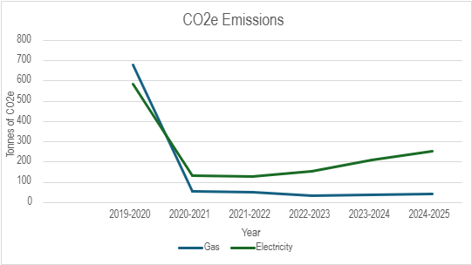

Gas consumption shown in the graph represents the council’s Scope 1 emissions, as it reflects on‑site fuel combustion within council buildings. Electricity consumption represents Scope 2 emissions, arising from the purchase of grid electricity used to operate buildings. Electricity‑related CO₂ emissions have increased primarily due to higher electricity consumption across council buildings. While the national electricity grid continues to decarbonise, this has been outweighed by increased demand, including electrified heating and building services. This reflects a shift away from fossil fuels rather than a deterioration in building performance. Although electricity‑related CO₂ emissions have increased, fuel switching has reduced on‑site combustion and therefore contributes positively to local air quality outcomes. The emissions from 2025-2026 are currently being calculated with the support from finance.

Through its Climate Change Strategy, the Council is delivering ongoing work to improve air quality by reducing emissions, supporting sustainable transport, and embedding cleaner practices across council operations and the wider borough. Hinckley and Bosworth Borough Council’s climate change strategy 2024-2028 was approved by the Council in January 2024. It identifies the actions we will take under six delivery themes. Further information can be found at: https://www.hinckley-bosworth.gov.uk/climatechange

Active Travel
Public Information on walking and cycling including led walks and cycle maps can be accessed through the Hinckley and Bosworth Borough Council website at
Walking | Hinckley & Bosworth Borough Council
Cycling for fitness, pleasure or transport | More about cycling | Hinckley & Bosworth Borough Council

A number of Active Travel objectives were delivered during 2025/26 via the UKSPF funded Active Travel project and the LCC Public Health funded Lets Get Moving Sport & Physical activity commissioning plan.
HBBC passed a new Travel and Subsidence Policy on 1st April 2026. Key points include;
- Introducing the travel hierarchy - encouraging staff to use the most sustainable form of travel from walking (being the most preferred choice), through to cycling, public transport, car sharing to using their own car (as the last option).
- Promotion of sustainable incentives to staff including salary sacrifice schemes such as cycle to work and electric cars (Ultra Low Emission Vehicles).
In August HBBC and Hinckley Bid showcased Cycling via the Hinckley Bike Spectacular event, with over 400 people reached at the event.

The internal HBBC staff intranet Health and Wellbeing site has had a refresh and incorporated in this a section around active travel and how aspects can support employees in responsible choices.

The Hinckley and Bosworth School Sports Partnership (HB SSPAN) delivered a number of projects including working with the LCC Choose How you Move team. SSPANs for two Active Travel Months (November and March) of which primary and secondary schools across the Borough took part in.

Choose How You Move is the lead agency (LCC) for Active Travel led initiatives in Leicestershire. A number of projects in 2025/26 benefitted residents in the H&B locality including E-Bike Training, Better Points Campaign and discounted bus travel in school holidays for children and young people. The Choose How You Move website is a one-stop shop for travel information in Leicester & Leicestershire. The website includes a journey planner to help explore different travel options that are available in Leicestershire. https://www.choosehowyoumove.co.uk/

Conclusions and Priorities
The Annual Status Report did not identify any exceedances of the Air Quality Objectives. A close eye will be kept on planning applications, developments to infrastructure and other factors likely to have an impact on Air Quality in the borough.

The borough has seen several major developments completed in recent years with more to follow. The planning process provides an opportunity for the local authority to manage future air quality and to identify and assess any planning applications which may impact upon air quality both during the construction and operational phases. Environmental Health (Environmental Protection) is consulted on planning applications and will assess the impact on air quality where necessary.

Hinckley & Bosworth Borough Council have declared a 'climate emergency'. Councillors have pledged to take local action to contribute to national carbon neutral targets through the development of practices and policies. Environmental Health (Environmental Protection) are engaged in this process. It is hoped that adopting more environmentally friendly practices and policies will help in improving air quality.

Environmental Health (Environmental Protection) will continue to engage with relevant partners to promote improvements in air quality.

How to get Involved
The principal pollutant of concern in the Borough of Hinckley and Bosworth is NO₂ from the road network. It follows that the best way to improve the air quality is to reduce emissions from vehicles. This can be done in a number of ways such as taking emissions into account when buying a new car to reducing dependence on private vehicles either by using public transport or using a more sustainable form of transport such as walking or cycling.

Information on walking and cycling including led walks and cycle maps can be accessed through the Hinckley and Bosworth Borough Council website at www.hinckley-bosworth.gov.uk

Choose How You Move is a partnership project between Leicester City Council and Leicestershire County Council, funded by the Department for Transport. The Choose How You Move website is a one-stop shop for travel information in Leicester & Leicestershire. The website includes a journey planner to help explore different travel options that are available in Leicestershire.

There are many small changes that you can make which will reduce your exposure and contribution to air pollution including:
- not using your car as often for short journeys and walking or cycling instead. You can find out more about the benefits of active travel on the Choose How You Move website
- reducing how much you burn in your home and garden
- if you choose to burn, switching to using cleaner fuels and to more efficient appliances
- opening your windows when you clean, do DIY, smoke, or do other activities that release pollutants directly into your home
- staying away from traffic if you’re walking or cycling (like walking on the side of the pavement furthest from the road, using the quieter roads and keeping back when waiting to cross the road)
- turning off your car engine when you park or are waiting in traffic

Table of Contents
Local Responsibilities and Commitment i
Executive Summary: Air Quality in Our Area iii
Actions to Improve Air Quality iv
Conclusions and Priorities xvii
How to get Involved xviii
1 Local Air Quality Management 1
2 Actions to Improve Air Quality 2
2.1 Air Quality Management Areas 2
2.2 Progress and Impact of Measures to address Air Quality in the Borough of Hinckley and Bosworth 3
2.3 PM_{2.5} – Local Authority Approach to Reducing Emissions and/or Concentrations 11
3 Air Quality Monitoring Data and Comparison with Air Quality Objectives and National Compliance 13
3.1 Summary of Monitoring Undertaken 13
3.1.1 Automatic Monitoring Sites 13
3.1.2 Non-Automatic Monitoring Sites 13
3.2 Individual Pollutants 13
3.2.1 Nitrogen Dioxide (NO₂) 13
3.2.2 Particulate Matter (PM₁₀) 15
3.2.3 Particulate Matter (PM_{2.5}) 15
3.2.4 Sulphur Dioxide (SO₂) 15
Appendix A: Monitoring Results 16
Appendix B: Full Monthly Diffusion Tube Results for 2025 21
Appendix C: Supporting Technical Information / Air Quality Monitoring Data QA/QC 23
New or Changed Sources Identified Within the Borough of Hinckley and Bosworth During 2025 23
Additional Air Quality Works Undertaken by Hinckley and Bosworth Borough Council During 2025 23
QA/QC of Diffusion Tube Monitoring 23
Diffusion Tube Annualisation 23
Diffusion Tube Bias Adjustment Factors 23
NO₂ Fall-off with Distance from the Road 25
Appendix D: Map(s) of Monitoring Locations and AQMAs 26
Appendix E: Summary of Air Quality Objectives in England 39
Glossary of Terms 40
References 41

Figures
Figure A.1 – Trends in Annual Mean NO₂ Concentrations 32
Figure D.1 – Map of Non-Automatic Monitoring Site 64
Tables

Table 2.2 – Progress on Measures to Improve Air Quality 10
Table A.1 – Details of Automatic Monitoring Sites 24
Table A.2 – Details of Non-Automatic Monitoring Sites 25
Table A.4 – Annual Mean NO₂ Monitoring Results: Non-Automatic Monitoring (µg/m³) 29

Table B.1 – NO₂ 2025 Diffusion Tube Results (µg/m³) 48

Table C.2 – Bias Adjustment Factor 54
Table E.1 – Air Quality Objectives in England 66

Local Air Quality Management
This report provides an overview of air quality in Hinckley and Bosworth Borough Council during 2025. It fulfils the requirements of Local Air Quality Management (LAQM) as set out in Part IV of the Environment Act (1995), as amended by the Environment Act (2021), and the relevant Policy and Technical Guidance documents.
The LAQM process places an obligation on all local authorities to regularly review and assess air quality in their areas, and to determine whether or not the air quality objectives are likely to be achieved. Where an exceedance is considered likely the local authority must declare an Air Quality Management Area (AQMA) and prepare an Air Quality Action Plan (AQAP) setting out the measures it intends to put in place in order to achieve and maintain the objectives and the dates by which each measure will be carried out. This Annual Status Report (ASR) is an annual requirement showing the strategies employed by Hinckley and Bosworth Borough Council to improve air quality and any progress that has been made.
The statutory air quality objectives applicable to LAQM in England are presented in Table E.1.

Actions to Improve Air Quality
  - Air Quality Management Areas
Air Quality Management Areas (AQMAs) are declared when there is an exceedance or likely exceedance of an air quality objective. After declaration, the authority should prepare an Air Quality Action Plan (AQAP) within 18 months. The AQAP should specify how air quality targets will be achieved and maintained, and provide dates by which measures will be carried out.
Hinckley and Bosworth Borough Council currently does not have any declared AQMAs. A local Air Quality Strategy is under development to prevent and reduce polluting activities.
  - Progress and Impact of Measures to address Air Quality in the Borough of Hinckley and Bosworth
Defra’s appraisal of last year’s ASR concluded:
“The report is well structured, detailed, and provides the information specified in the Guidance. The following comments are designed to help inform future reports:
1. There are a few instances where NO₂, PM₁₀, and PM_{2.5} are missing subscripts. This should be amended.
2. It is stated on Page 13 that “the following measures are taken in the Borough to reduce PM_{2.5} “. However, no measures appear to be listed.
3. It should be noted that it is stated there are 16 sites in Section 3.1.2, however this appears to be the number of diffusion tubes. One site, DT10, 12, 14, is a triplicate site. The Council should be wary of this discrepancy in future ASRs.
4. A clear trend chart has been provided to show the trends in annual mean NO₂ concentrations across the past five years. The use of a line to indicate the air quality objective is helpful.
5. Clear maps have been provided to indicate the locations of monitoring sites. A map showing an overview of the whole network would be beneficial.
6. The Council are commended for their in-depth discussion regarding measures to reduce PM_{2.5} emissions. This should be continued in future ASRs.
7. It is acknowledged that HBBC have started to development a Local Air Quality Strategy. An update on this should be provided in the next ASR.”

Hinckley and Bosworth Borough Council has taken forward a number of direct measures during the current reporting year of 2025 in pursuit of improving local air quality. Details of all measures completed, in progress or planned are set out in Table 2.2. 23 measures are included within Table 2.2, with the type of measure and the progress Hinckley and Bosworth Borough Council have made during the reporting year of 2025 presented. Where there have been, or continue to be, barriers restricting the implementation of the measure, these are also presented within Table 2.2.

Hinckley and Bosworth Borough Council’s priorities for the coming year are:
- To publish the Air Quality Strategy
- To continue to engage with LCC regarding any changes to the transport infrastructure.
- To continue engaging with Leicestershire Authorities and stakeholders at both the Leicestershire Air Quality Forum and the Leicestershire Air Quality and Health Partnership with the aim of sharing knowledge and disseminating best practice.
- To continue to roll out updated guidance for developers at the planning stage of projects.
- To continue to review the existing diffusion tube monitoring sites and relocate resources as appropriate taking into account planned development.
- Hinckley and Bosworth Borough Council anticipates that the measures stated above and in Table 2.2 will achieve compliance with the Air Quality Objective Limits.

Hinckley and Bosworth Borough Council worked to implement these measures in partnership with the following stakeholders during 2024:
- Leicestershire County Council;
- Leicestershire Air Quality Forum
- Leicestershire Air Quality and Health Partnership

The principal challenges and barriers to implementation that Hinckley and Bosworth Borough Council anticipates facing are:
• The Borough of Hinckley and Bosworth is located within what is known as The Golden Triangle of Logistics which, with access to several major motorways, provides access to over 90% of the UK population within 4 hours. The Golden Triangle has close to 14 million m2 of warehouse space; more than twice the combined warehousing activity of London, Scotland and Wales. This provides a strong desire for B8 (Storage or Distribution) development which, while bringing in clear economic benefits does present challenges to air quality on the local road network.
• A major challenge relates to working in a two tier authority with Environmental Health and Highways working in separate authorities. This is in part addressed through the Leicestershire Air Quality Forum and Air Quality and Health Partnership where professionals from various agencies meet to discuss air quality issues in the region and best practice.

Table 2.2 – Progress on Measures to Improve Air Quality
Measure No. | Measure Title | Category | Classification | Year Measure Introduced in AQAP | Estimated / Actual Completion Date | Organisations Involved | Funding Source | Funding Status | Estimated Cost of Measure | Measure Status | Reduction in Pollutant / Emission from Measure | Key Performance Indicator | Progress to Date | Comments / Barriers to Implementation
Priority Air Quality Actions
1 | Planning Policy- Site Allocations and Development Management Policies Development Plan | Policy Guidance and Development Control | Other policy | 2016 | ongoing | HBBC | Local Authority Funding | Not Funded | £100k - £500k | Implementation | Reduction in general emissions as developers need to demonstrate that applications will not contribute to poor air quality | Developers assess air quality as required. | The Site Allocations and Development Management Policies (SADMP) Development Plan was formally adopted on 12 July 2016. | The SADMP requires that adverse impacts from air pollution will be prevented by ensuring that development proposals demonstrate that they will not contribute to poor air quality.
2 | Sustainable Travel Initiatives | Promoting travel alternatives | Intensive active travel campaign & infrastructure | 2022 | ongoing | LCC, HBBC | funding source e.g. Developers & highway infrastructure funding | Partially Funded | £100k - £500k | Implementation | Reduction in vehicle emissions | Increase in cycling and walking and wheeling trips. | To include:  car sharing, E-Bike try outs, cycle and public transport awareness campaigns, Dr Bike, business grants, Bikeability cycle training for year 5 and 6 pupils, adult cycle courses, Leicestershire’s Bike Bank, Leicestershire’s Bike Library, Modeshift Inspector Programme, Healthy Streets audits. Better Points scheme  Under the Choose How you Move brand: www.choosehowyoumove.co.uk | Actively working with businesses and schools to support them in developing travel plans and delivering safe and sustainable travel initiatives.
3 | Strategic Road Network | Traffic Management | Strategic Highway Improvements | 2022 | 2024 | National Highways, LCC, HBBC | National Highways, Gov funding | Not Funded | > £10 million | Implementation | Not possible to estimate | N/A | Continued dialogue with National Highways | Updates via National Highways, route improvements and future strategies
4 | Prevent and/or reduce environmental impacts from domestic and commercial emissions. Control of dust and smoke Bonfires | Other | Other | Ongoing | Ongoing | HBBC Environmental Health | Local Authority Funding | Not Funded | £50k - £100k | Implementation | Reduced particulate matter | Low number of Commercial Smoke Complaints 2025- 16  2024- 15  2023-22 2022 - 10  2021 - 25 2020- 54  Low number of Domestic smoke complaints 2025- 52  2024- 71 2023- 62 2022- 69 2021- 95 2020- 143 | Implementation on-going | smoke complaints continue to show a general downward trajectory.
5 | Environmental Permits | Environmental Permits | Introduction/increase of environment charges through permit systems and economic instruments | Ongoing | Ongoing | HBBC Environmental Health | Local Authority Funding | Not Funded | £10k - 50k | Implementation | Reduced Emissions of regulated pollutants | Permitted Processes attaining best achievable risk rating | All processes are inspected as per DEFRA guidance. | 100% of planned inspections of permitted processes were completed in 2025.
6 | Environmental Permits | Environmental Permits | Tradable permit system through permit systems and economic instruments | Ongoing | Ongoing | HBBC | Local Authority Funding | Not Funded | < £10k | Implementation | Reduced Co₂ and related emissions | Permitted Process compliance with EU ETS | One Environmental Permit has been varied and now includes a condition requiring compliance with the EU EmissionsTrading Scheme | The Environment Agency regulate the EU ETS a condition applied through the Environmental Permit provides a further incentive to comply with the scheme.
7 | Active Travel | Promoting Travel Alternatives, | Intensive active travel campaign & infrastructure | Ongoing | Ongoing | HBBC, LCC | Local Authority Funding | Not Funded | £10k - 50k | Completed | Reduction in vehicle emissions |  | The Hinckley and Bosworth School Sports Partnership (HB SSPAN) delivered a number of projects including working with the LCC Choose How you Move team. SSPANs for two Active Travel Months (November and March) of which primary and secondary schools across the Borough took part in. | Choose How You Move is the lead agency (LCC) for Active Travel led initiatives in Leicestershire. A number of projects in 2025/26 benefitted residents in the H&B locality including E-Bike Training, Better Points Campaign and discounted bus travel in school holidays for children and young people. The Choose How You Move website is a one-stop shop for travel information in Leicester & Leicestershire. The website includes a journey planner to help explore different travel options that are available in Leicestershire. https://www.choosehowyoumove.co.uk/
8 | EV | Promoting Low Emission Transport | Procuring alternative Refuelling infrastructure to promote Low Emission Vehicles, EV recharging, Gas fuel recharging | ongoing | ongoing | HBBC | 25% local authority, 75% OLEV funding (DFT) | Partially Funded | £50k - £100k | Completed | Reduction in vehicle emissions | Works completed | Castle Car Park, Hinckley (6)  Jubilee Building (Private) Hinckley (2)  Lower Bond Street Hinckley (6)  Hallfields Car Park Earl Shilton (4)  Rectory Lane Market Bosworth (3)  Stanley Street Barwell, (4)
9 | Fleet review | Vehicle Fleet Efficiency | Fleet efficiency and recognition schemes | Ongoing | Ongoing | HBBC | Local Authority Funding |  |  | Completed | Reduction in HBBC fleet emissons | Works completed | As of the end of March 2026 HBBC have 80 vehicles using HVO. The current fuel breakdown is 97.8% HVO and 2.2% Derv/Petrol.
10 | Taxi Licensing Conditions | Promoting Low Emission Transport | Taxi Licensing Conditions | 2022 | Ongoing | HBBC |  |  | Local Authority Funding | Completed | Reduction in emissions from licenced vehicles | Works completed | As of November 2022 any vehicle applying for the grant of a new taxi or private hire licence will need to be less than 6 years old when first licensed and comply with one of the following vehicle emission standards: Euro 6 petrol or Euro 6 diesel, Ultra-low emissions vehicle (ULEV), Zero emissions vehicle (ZEV)
11 | Air Quality Monitoring | Other | Other | 2023 | ongoing | Environmental Services Team | Developer funding, Defra AQ Grant | Partially funded | £10k - £50k | Implementation | Not applicable | Not applicable | Funding in place. Monitoring ongoing with programme under review
12 | Traffic Data Collection | Traffic Management | Other | 2023 | ongoing | LCC | Developers & highway infrastructure funding | Fully funded | £100k - £500k | Ongoing, demand led | Not applicable | Not applicable | Funding secured
13 | Liaison with local Councils | Public Information | Other | 2023 | ongoing | Parish Councils, Braunstone Town Council, Parish Meetings | HBBC,Defra AQ Grant | Partially funded | <£10k | Planning | Not applicable | Not applicable
14 | Air Quality Information available on Borough Council’s website | Public Information | Via the Internet | 2023 | ongoing | HBBC | HBBC,Defra AQ Grant | Partially funded | <£10k | Planning | Not possible to estimate | Information available on the district website
15 | Air Quality and Health Partnership Comms plan | Public Information | Via the Internet | 2023 | ongoing | HBBC, LCC | HBBC, Defra AQ Grant | Partially funded | <£10k | Planning | Not possible to estimate | Not applicable | Communications including Clean Air Day, active travel etc. Further work to provide further information available to the public is currently in the planning stage.
16 | Air Quality and Health Partnership | Policy Guidance and Development Control | County group Co-ordinating programmes to develop Area wide Strategies to reduce emissions and improve air quality | 2022 | ongoing | HBBC, LCC, Public Health, NWL, HDC, MBC, CBC, O&W, BDC. | Public Health | Partially funded | < £10k | Planning | Not possible to estimate | Not applicable
17 | Local Plan | Policy Guidance and Development Control | Other Policy | 2022 | Ongoing | HBBC, LCC | HBBC, LCC funded | Partially Funded | £1 million - £10 million | Planning | Reduction in vehicle emissions | Not applicable |  | Next Local Plan
18 | Work with HBBC to secure necessary mitigation measures to support new development and ensure it is located where appropriate | Policy Guidance and Development Control | Other Policy | 2022 | Ongoing | HBBC, LCC | HBBC, LCC, Developer funding, | Partially Funded | £100k - £500k | Planning | Not possible to estimate | Not applicable |  | Convenient access to local amenities, public transport and walking and cycling facilities with the intention of reducing car journeys and avoiding creating future air quality problems.
19 | Work with Leicestershire County Council to input to a strategy and implementation plan to create an integrated charging network across the district (public and private car parks, petrol stations, on street) | Promoting Low Emission Transport | Procuring alternative Refuelling infrastructure to promote Low Emission Vehicles, EV recharging, Gas fuel recharging | 2024 | Delivery of EV Strategy and Implementation Plan is ongoing | HBBC, LCC | Private, Developer, and Central Government Funding | Funded | £1 million - £10 million | Planning | Reduction in vehicle emissions | Number of EV charging points per 100,000 population. District owned chargepoints to be delivered | Funding and resourcing being sought for strategy implementation | Resources
20 | Work with LCC on the Pilot LEVI Fund | Promoting Low Emission Transport | Procuring alternative Refuelling infrastructure to promote Low Emission Vehicles, EV recharging, Gas fuel recharging | 2023 | Ongoing | HBBC, LCC | Private, Developer, and Central Government Funding | Funded | £1 million - £10 million | Planning | Reduction in vehicle emissions | Number of EV charging points per 100,000 population. District owned chargepoints to be delivered | Initial pilot Funding has been secured for a limited number of charge points installed, owned and operated by the appointed chargepoint operator appointed (Wenea). | Resources
21 | Local Cycling and Walking Infrastructure Plans (LCWIPs) | Transport Planning and Infrastructure | Cycle Network | 2023 | Ongoing | HBBC, LCC, DfT, Active Travel England (ATE) | Developer, and Central Government Funding |  | £1 million - £10 million + | Planning | Modal Shift to reduce vehicle use/ emissions | Cycling and walking stats will become available as the LCWIP progresses | Hinckley-area walking and cycling networks were identified in February 2026. Healthy Streets route auditing and design work is now underway, with proposals and supporting documents targeted for completion within autumn 2026.  The North of Leicester LCWIP area (covering the eastern part of the borough) will be revisited and progressed thereafter. | Actively working with businesses and schools to support them in developing travel plans and planning deliverable, safe, and sustainable travel initiatives.
22 | Demand Related Transport | Alternatives to private vehicle use | Other: Public transport lift sharing scheme | 2022 | ongoing | Bus companies, HBBC, LCC | Central Government funding | Funded | £1 million - £10 million | Implementation | Reduction in vehicle emissions | N/A | 11 FoxConnect zones operate in Leicestershire. South West Leicestershire continues to have provision in the form of DRT (zone 10) along with a fixed bus service to Fosse Park and Hinckley. | FoxConnect implemented and in use.
23 | Leicestershire Enhanced Bus Partnership | Alternatives to private vehicle use | Other: Increase use on Public Transport | 2022 | ongoing | Bus companies, HBBC, LCC | Subject to funding | Partially Funded | £1 million - £10 million | Implementation | Reduction in vehicle emissions | Reduced bus emissions and increase bus use (modal shift) | The partnership between bus operators and the County Council remains ongoing. The passenger transport network review of supported services has now been completed, with the next phase focused on monitoring these services and evaluating the trial services introduced.  The LC6 service, connecting Hinckley to Coalville, was introduced as a trial in response to passenger feedback. A recent discount promotion over the Easter period was designed to encourage group travel, with further promotional initiatives currently being developed in partnership with operators. | Fully funded subject to fare revenue and uptake

  - PM_{2.5} – Local Authority Approach to Reducing Emissions and/or Concentrations
As detailed in Policy Guidance LAQM.PG22 (Chapter 8) and the Air Quality Strategy, local authorities are expected to work towards reducing emissions and/or concentrations of fine particulate matter (PM_{2.5})). There is clear evidence that PM_{2.5} (particulate matter smaller than 2.5 micrometres) has a significant impact on human health, including premature mortality, allergic reactions, and cardiovascular diseases.

Public Health Profiles is a data tool provided by OHID (Office of Health Improvement and Disparities). Hinckley and Bosworth Borough Council has used the tool to generate an indication as to the mean average levels of PM_{2.5} and the fraction of mortality attributable to particulate air pollution across the borough. Table 2.3 below shows the data set against both local and national figures. Based upon the latest available figures (2024).
Table 2.3 Fraction of mortality attributable to particulate air pollution (new method) and concentrations of total PM_{2.5} (2024).
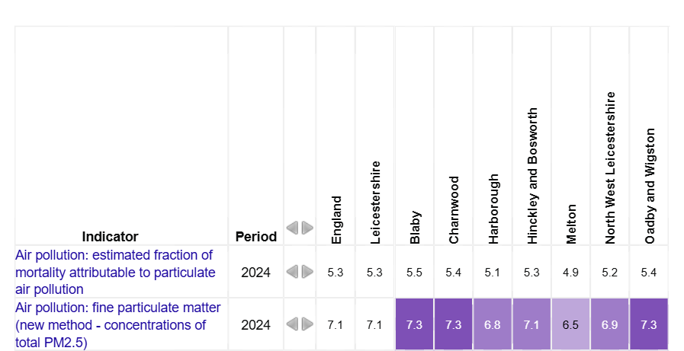

In addition to the measures in table 2.2 the following considerations are noted and will assist the Borough in reducing PM_{2.5}:

Hinckley and Bosworth Borough Council have used the DEFRA National Background Maps for PM_{2.5} to determine the locations where higher concentrations of PM_{2.5} are likely.

The source apportionment data provided in the maps allows HBBC to identify sources of PM_{2.5} in hotspot areas. This will allow HBBC to evaluate existing control measures and amend these if necessary.

The majority of sources identified from the maps where PM_{2.5} is likely to be generated in the borough are sites controlled by the Pollution Prevention and Control regime. HBBC has several permitted processes in the borough which are regularly inspected by Environmental Health (Pollution) using a risk rating system. Emissions are monitored at sites either continually or annually to ensure compliance with current Emission Limit Values (ELVs) where these are necessary. Permit conditions require operators to inform Environmental Health (Pollution) of any exceedances of ELVs.

Under the planning process air quality impact assessments will be required for developments likely to affect air quality. Reports will include impacts from PM_{2.5}. Environmental Health (Pollution) has recently updated the guidance given to developers regarding air quality and more emphasis is placed on PM_{2.5}.

Domestic wood and coal fires are the largest contributors to Particulate emissions - almost 38% according to DEFRA’s Clean Air Strategy. This compares to emissions from industrial combustion (17%) and road transport (13%). The tiny particles in smoke can cause a range of health impacts such as breathing problems and exacerbating asthma as well as contributing to other health conditions. Hinckley and Bosworth Borough Council raises awareness of the impacts of solid fuel burning both during the investigating of complaints and by providing relevant information on the council website. Where appropriate enforcement action will be taken under clean air, nuisance or anti-social behaviour legislation.

Air Quality Monitoring Data and Comparison with Air Quality Objectives and National Compliance
This section sets out the monitoring undertaken within 2025 by Hinckley and Bosworth Borough Council and how it compares with the relevant air quality objectives. In addition, monitoring results are presented for a five-year period between 2021 and 2025 to allow monitoring trends to be identified and discussed.
  - Summary of Monitoring Undertaken

Automatic Monitoring Sites
Hinckley and Bosworth Borough Council does not operate any automatic monitoring sites.

Non-Automatic Monitoring Sites
Hinckley and Bosworth Borough Council undertook non- automatic (i.e. passive) monitoring of NO₂ at 14 sites during 2025. Table A.2 in Appendix A presents the details of the non-automatic sites.
Maps showing the location of the monitoring sites are provided in Appendix D. Further details on Quality Assurance/Quality Control (QA/QC) for the diffusion tubes, including bias adjustments and any other adjustments applied (e.g. annualisation and/or distance correction), are included in Appendix C.
  - Individual Pollutants
The air quality monitoring results presented in this section are, where relevant, adjusted for bias, annualisation (where the annual mean data capture is below 75% and greater than 25%), and distance correction. Further details on adjustments are provided in Appendix C.

Nitrogen Dioxide (NO₂)
Table A.3 and Table A.4 in Appendix A compare the ratified and adjusted monitored NO₂ annual mean concentrations for the past five years with the air quality objective of 40µg/m³. Note that the concentration data presented represents the concentration at the location of the monitoring site, following the application of bias adjustment and annualisation, as required (i.e. the values are exclusive of any consideration to fall-off with distance adjustment).
For diffusion tubes, the full 2025 dataset of monthly mean values is provided in Appendix B. Note that the concentration data presented in Table B.1 includes distance corrected values, only where relevant.
Table A.5 in Appendix A compares the ratified continuous monitored NO₂ hourly mean concentrations for the past five years with the air quality objective of 200µg/m³, not to be exceeded more than 18 times per year.

Table A.2 shows that no sites across the borough indicated exceedances of the Air Quality Objectives at relevant exposures in 2025. No AQMA’s have been declared.

Following the 2012 Progress Report sites 10 and 14 were established to provide additional monitoring to the existing site 12 at 6 Shaw Lane, Markfield. This site had measured possible marginal exceedances of the Air Quality Objective for NO₂ in that report. A Detailed Assessment was carried out of this area in 2015. The results of the detailed assessment showed that the Air Quality Objective Values were not exceeded and an Air Quality Management Area was not declared. The site has been closely monitored since and levels of NO₂ have improved significantly since measures were taken to improve traffic flows on the adjacent roundabout. The site has consistently measured levels of NO₂ comfortably within the Air Quality Objective Values for several years and in 2026 the site was reduced from triplicate to a single diffusion tube. 2 diffusion tubes have been relocated following a review of the monitoring network.

In 2020 all monitoring sites were reviewed. A diffusion tube monitoring site was established on Groby Road in Ratby in 2020 (site 13) to monitor levels of NO₂ close to the M1. The results of 5 years of monitoring indicate that the Air Quality Objectives are not being exceeded at this site. This site has been discontinued in 2026 and the diffusion tube relocated.

Site 5 was established to measure levels of NO₂ along Peckleton Lane in Desford. The adjacent land received planning permission for a storage and distribution site. The results of the monitoring indicate that the Air Quality Objectives are not being exceeded at this site at present. Monitoring will continue to assess the impact of the development now that it is operational.

Analysis of measurements across the UK has shown that the 1 hour NO₂ objective is not likely to be exceeded unless the annual mean is above 60µg/m3 (Laxton & Marner 2003). Exceedance of 60µg/m3 annual mean can be used as a surrogate index for breaches of the hourly objective. Table A2 in appendix A shows that none of the HBBC monitoring sites had annual mean values approaching 60µg/m3 so it is unlikely that the hourly objective has been exceeded at any of them.

Particulate Matter (PM₁₀)
HBBC does not monitor PM₁₀

Particulate Matter (PM_{2.5})
HBBC does not monitor PM_{2.5}

Sulphur Dioxide (SO₂)
HBBC does not monitor SO₂.

Appendix A: Monitoring Results
Table A.2 – Details of Non-Automatic Monitoring Sites
Diffusion Tube ID | Site Name | Site Type | X OS Grid Ref (Easting) | Y OS Grid Ref (Northing) | Pollutants Monitored | In AQMA? Which AQMA? | Distance to Relevant Exposure (m) ⁽¹⁾ | Distance to kerb of nearest road (m) ⁽²⁾ | Tube Co-located with a Continuous Analyser? | Tube Height (m)
1 | Trinity Lane | Urban Centre | 442417 | 293808 | NO₂ | No AQMA | 0.0 | 3.0 | No | 2.0
2 | 1 Rufford Close | Suburban | 442903 | 291349 | NO₂ | No AQMA | 0.0 | 7.0 | No | 2.0
3 | 562 Coventry Road | Suburban | 440106 | 293080 | NO₂ | No AQMA | 0.0 | 16.0 | No | 2.0
4 | Rivendell A5 | Suburban | 439736 | 293244 | NO₂ | No AQMA | 0.0 | 21.0 | No | 2.0
5 | Peckleton Lane Desford | Suburban | 448012 | 302544 | NO₂ | No AQMA | 14.0 | 1.0 | No | 2.0
6 | 207 Rugby Road, Burbage | Suburban | 442592 | 292938 | NO₂ | No AQMA | 0.0 | 9.0 | No | 2.0
7 | 66 London Road | Suburban | 443624 | 293829 | NO₂ | No AQMA | 0.0 | 10.0 | No | 2.0
8 | Wood Street, Earl Shilton | Urban Centre | 446320 | 297756 | NO₂ | No AQMA | 5.0 | 1.0 | No | 2.5
9 | Shilton Bypass | Suburban | 446696 | 296771 | NO₂ | No AQMA | 24.0 | 6.0 | No | 2.0
11 | 216 Markfield Road, Groby | Suburban | 451376 | 308147 | NO₂ | No AQMA | 0.0 | 13.0 | No | 2.0
13 | 36 Groby Road, Ratby | Suburban | 451560 | 306273 | NO₂ | No AQMA | 0.0 | 18.0 | No | 1.7
10, 12, 14 | 6 Shaw Lane | Rural | 447113 | 311660 | NO₂ | No AQMA | 0.0 | 8.0 | No | 1.7
15 | 93 Rugby Road, Hinckley | Urban Centre | 442291 | 293579 | NO₂ | No AQMA | 0.0 | 5.0 | No | 2.0
16 | 171 Rugby Road, Hinckley | Suburban | 442328 | 293264 | NO₂ | No AQMA | 0.0 | 7.0 | No | 2.0
Notes:
(1) 0m if the monitoring site is at a location of exposure (e.g. installed on the façade of a residential property).
(2) N/A if not applicable.
Table A.4 – Annual Mean NO₂ Monitoring Results: Non-Automatic Monitoring (µg/m³)
Diffusion Tube ID | X OS Grid Ref (Easting) | Y OS Grid Ref (Northing) | Site Type | Valid Data Capture for Monitoring Period (%) ⁽¹⁾ | Valid Data Capture 2025 (%) ⁽²⁾ | 2021 | 2022 | 2023 | 2024 | 2025
1 | 442417 | 293808 | Urban Centre | 100.0 | 100.0 | 17.1 | 16.3 | 15.7 | 14.6 | 15.2
2 | 442903 | 291349 | Suburban | 100.0 | 100.0 | 22.8 | 22.5 | 20.4 | 18.9 | 17.1
3 | 440106 | 293080 | Suburban | 100.0 | 100.0 | 18.9 | 18.2 | 16.7 | 15.8 | 15.8
4 | 439736 | 293244 | Suburban | 100.0 | 100.0 | 18.2 | 17.8 | 16.8 | 14.7 | 13.8
5 | 448012 | 302544 | Suburban | 100.0 | 100.0 | 10.9 | 12.4 | 11.4 | 9.5 | 9.7
6 | 442592 | 292938 | Suburban | 100.0 | 100.0 | 17.0 | 16.4 | 15.4 | 13.8 | 17.6
7 | 443624 | 293829 | Suburban | 90.4 | 90.4 | 17.6 | 18.1 | 16.4 | 14.6 | 14.9
8 | 446320 | 297756 | Urban Centre | 75.0 | 75.0 | 21.6 | 19.1 | 17.7 | 16.2 | 17.3
9 | 446696 | 296771 | Suburban | 100.0 | 100.0 | 17.2 | 17.7 | 15.8 | 13.8 | 13.7
11 | 451376 | 308147 | Suburban | 100.0 | 100.0 | 18.8 | 18.1 | 17.1 | 13.8 | 15.6
13 | 451560 | 306273 | Suburban | 100.0 | 100.0 | 15.9 | 15.3 | 15.3 | 12.2 | 13.9
10, 12, 14 | 447113 | 311660 | Rural | 100.0 | 100.0 | 28.8 | 27.1 | 26.1 | 24.2 | 21.4
15 | 442291 | 293579 | Urban Centre | 100.0 | 100.0 | 25.5 | 23.6 | 21.5 | 21.6 | 21.2
16 | 442328 | 293264 | Suburban | 100.0 | 100.0 | 18.6 | 18.9 | 17.5 | 15.3 | 14.9
☒ Diffusion tube data has been bias adjusted.
☒ Reported concentrations are those at the location of the monitoring site (bias adjusted and annualised, as required), i.e. prior to any fall-off with distance correction.
Notes:
The annual mean concentrations are presented as µg/m³.
Exceedances of the NO₂ annual mean objective of 40µg/m³ are shown in bold.
NO₂ annual means exceeding 60µg/m³, indicating a potential exceedance of the NO₂ 1-hour mean objective are shown in bold and underlined.
Means for diffusion tubes have been corrected for bias.
Concentrations are those at the location of monitoring and not those following any fall-off with distance adjustment.

Figure A.1 – Trends in Annual Mean NO₂ Concentrations

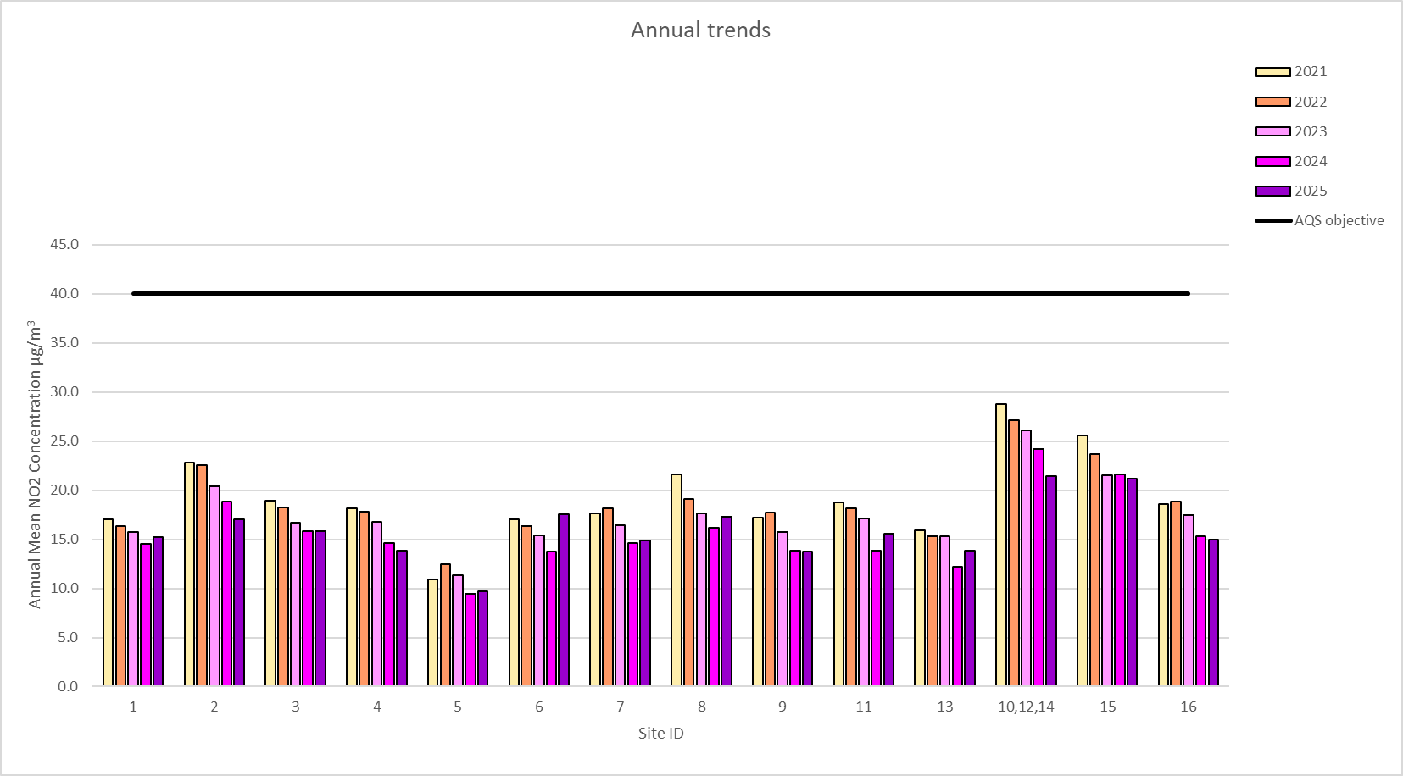

Appendix B: Full Monthly Diffusion Tube Results for 2025
Table B.1 – NO₂ 2025 Diffusion Tube Results (µg/m³)
DT ID | X OS Grid Ref (Easting) | Y OS Grid Ref (Northing) | Jan | Feb | Mar | Apr | May | Jun | Jul | Aug | Sep | Oct | Nov | Dec | Annual Mean: Raw Data | Annual Mean: Annualised and Bias Adjusted  0.78 | Annual Mean: Distance Corrected to Nearest Exposure | Comment
1 | 442417 | 293808 | 36.8 | 28.0 | 23.2 | 17.9 | 12.3 | 12.7 | 13.8 | 13.6 | 16.6 | 13.6 | 24.2 | 21.2 | 19.5 | 15.2
2 | 442903 | 291349 | 36.3 | 29.7 | 20.5 | 19.1 | 14.9 | 24.9 | 18.2 | 22.8 | 21.0 | 0.9 | 28.4 | 25.8 | 21.9 | 17.1
3 | 440106 | 293080 | 30.3 | 28.2 | 16.8 | 17.8 | 15.3 | 17.2 | 16.2 | 16.3 | 20.2 | 17.0 | 25.4 | 22.5 | 20.3 | 15.8
4 | 439736 | 293244 | 26.3 | 25.5 | 17.7 | 8.9 | 11.1 | 16.5 | 13.7 | 14.5 | 15.0 | 19.5 | 22.2 | 22.0 | 17.7 | 13.8
5 | 448012 | 302544 | 22.5 | 15.6 | 13.9 | 8.4 | 5.2 | 9.5 | 9.4 | 9.0 | 12.2 | 10.0 | 17.9 | 15.1 | 12.4 | 9.7
6 | 442592 | 292938 | 23.9 | 27.6 | 23.0 | 13.2 | 13.6 | 71.8 | 14.2 | 11.8 | 15.4 | 17.2 | 17.3 | 21.2 | 22.5 | 17.6
7 | 443624 | 293829 | 29.9 | 22.8 | 21.1 | 13.9 | 11.3 | 14.8 |  | 14.9 | 14.9 | 20.7 | 23.2 | 22.1 | 19.1 | 14.9
8 | 446320 | 297756 | 35.9 | 24.8 | 30.3 |  | 19.1 | 15.0 | 14.2 | 17.0 |  |  | 20.7 | 23.0 | 22.2 | 17.3
9 | 446696 | 296771 | 26.7 | 26.6 | 18.8 | 13.8 | 13.2 | 13.0 | 10.4 | 13.5 | 16.2 | 16.5 | 21.3 | 21.2 | 17.6 | 13.7
10 | 447113 | 311660 | 39.0 | 34.0 | 32.6 | 18.7 | 23.0 | 27.4 | 23.5 | 24.4 | 26.7 | 29.2 | 30.7 | 26.0 | - | -
11 | 451376 | 308147 | 31.5 | 25.5 | 20.4 | 15.6 | 9.1 | 18.3 | 16.1 | 17.2 | 18.9 | 13.5 | 28.6 | 25.4 | 20.0 | 15.6
12 | 447113 | 311660 | 37.5 | 35.4 | 30.5 | 23.7 | 23.8 | 28.5 | 26.1 | 25.0 | 23.3 | 11.7 | 29.5 | 26.4 | - | -
13 | 451560 | 306273 | 20.7 | 22.2 | 24.7 | 11.3 | 15.3 | 11.3 | 13.9 | 13.0 | 14.9 | 30.8 | 18.9 | 16.3 | 17.8 | 13.9
14 | 447113 | 311660 | 37.1 | 34.8 | 30.6 | 23.2 | 24.9 | 28.4 | 22.2 | 26.5 | 25.2 | 20.9 | 30.9 | 27.4 | 27.5 | 21.4
15 | 442291 | 293579 | 38.6 | 34.8 | 33.0 | 15.9 | 20.9 | 22.6 | 23.0 | 20.9 | 24.8 | 28.5 | 32.1 | 30.7 | 27.2 | 21.2
16 | 442328 | 293264 | 28.3 | 27.9 | 23.6 | 13.8 | 13.3 | 15.6 | 13.5 | 17.4 | 18.3 | 18.2 | 18.6 | 21.3 | 19.2 | 14.9
☒ National bias adjustment factor used.
☒ Where applicable, data has been distance corrected for relevant exposure in the final column
☒ HBBC confirm that all 2025 diffusion tube data has been uploaded to the Diffusion Tube Data Entry System.
Notes:
Exceedances of the NO₂ annual mean objective of 40µg/m³ are shown in bold.
NO₂ annual means exceeding 60µg/m³, indicating a potential exceedance of the NO₂ 1-hour mean objective are shown in bold and underlined.
See Appendix C for details on bias adjustment and annualisation.

Appendix C: Supporting Technical Information / Air Quality Monitoring Data QA/QC

New or Changed Sources Identified Within the Borough of Hinckley and Bosworth During 2025
Hinckley and Bosworth Borough Council has not identified any new sources relating to air quality within the reporting year of 2025.

Additional Air Quality Works Undertaken by Hinckley and Bosworth Borough Council During 2025
Hinckley and Bosworth Borough Council has not completed any additional works within the reporting year of 2025.

QA/QC of Diffusion Tube Monitoring
Monitoring throughout 2025 was completed in adherence with the 2025 Diffusion Tube Monitoring Calendar

Diffusion Tube Annualisation
All diffusion tube monitoring locations within the Borough of Hinckley and Bosworth recorded data capture of 75% therefore it was not required to annualise any monitoring data.

Diffusion Tube Bias Adjustment Factors
The diffusion tube data presented within the 2026 ASR have been corrected for bias using an adjustment factor. Bias represents the overall tendency of the diffusion tubes to under or over-read relative to the reference chemiluminescence analyser. LAQM.TG22 provides guidance with regard to the application of a bias adjustment factor to correct diffusion tube monitoring. Triplicate co-location studies can be used to determine a local bias factor based on the comparison of diffusion tube results with data taken from NO_{x}/NO₂ continuous analysers. Alternatively, the national database of diffusion tube co-location surveys provides bias factors for the relevant laboratory and preparation method.

Hinckley and Bosworth Borough Council have applied a national bias adjustment factor of 0.78 to the 2025 monitoring data. A summary of bias adjustment factors used by Hinckley and Bosworth Borough Council over the past five years is presented in Table C.2.

Hinckley and Bosworth Borough Council diffusion tubes are supplied and analysed by SOCOTEC Didcot. They prepare the tubes using 50% Triethanolamine (TEA) in acetone. SOCOTEC have confirmed that they meet the guidelines set out in DEFRA’s ‘Diffusion Tubes for Ambient NO₂ Monitoring: Practical Guidance.’

In the AIR PT intercomparison scheme for comparing spiked Nitrogen Dioxide diffusion tubes, SOCOTEC currently holds the highest rank of a “Satisfactory” laboratory.

Bias adjustment factors used are from the Review and Assessment website (Spreadsheet Version Number: 03/26). The factor used was 0.78. The number of studies applicable to the factor was 17.

Table C.2 – Bias Adjustment Factor

Monitoring Year | Local or National | If National, Version of National Spreadsheet | Adjustment Factor
2025 | National | 03/26 | 0.78
2024 | National | 04/25 | 0.78
2023 | National | 03/24 | 0.77
2022 | National | 03/23 | 0.76
2021 | National | 03/22 | 0.78

NO₂ Fall-off with Distance from the Road
Wherever possible, monitoring locations are representative of exposure. However, where this is not possible, the NO₂ concentration at the nearest location relevant for exposure has been estimated using the Diffusion Tube Data Processing Tool.
No diffusion tube NO₂ monitoring locations within the Borough of Hinckley and Bosworth required distance correction during 2025.

Appendix D: Map(s) of Monitoring Locations and AQMAs
Figure D.1 – Map of Non-Automatic Monitoring Site
Map 1. Site 1:Trinity Court Hinckley
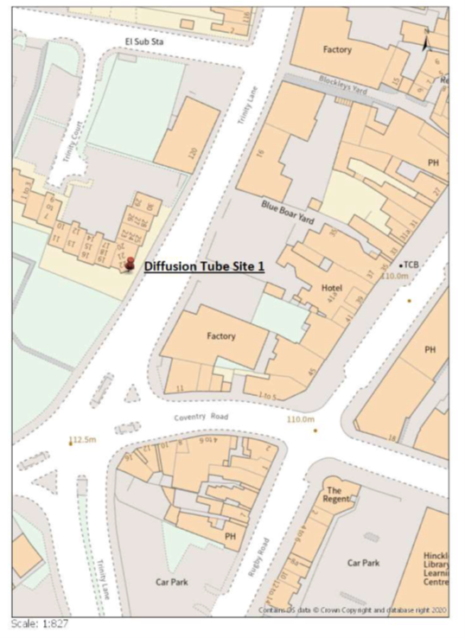

Map 2. Site 2: 1 Rufford Close Burbage
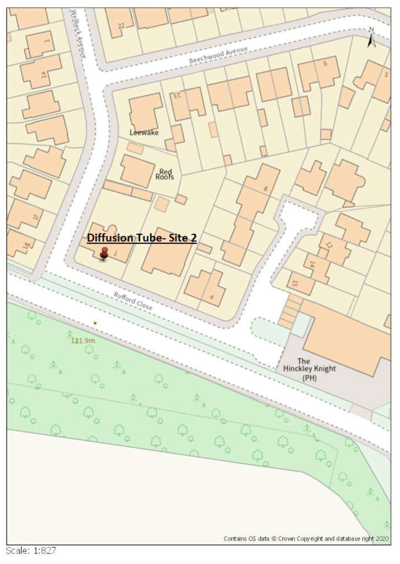

Map 3 Site 3: 562 Coventry Road, Hinckley (Red Pin) Site 4: Rivendell Watling Street (A5) (Blue Pin)

Map 4 Site 5: Peckleton Lane Desford
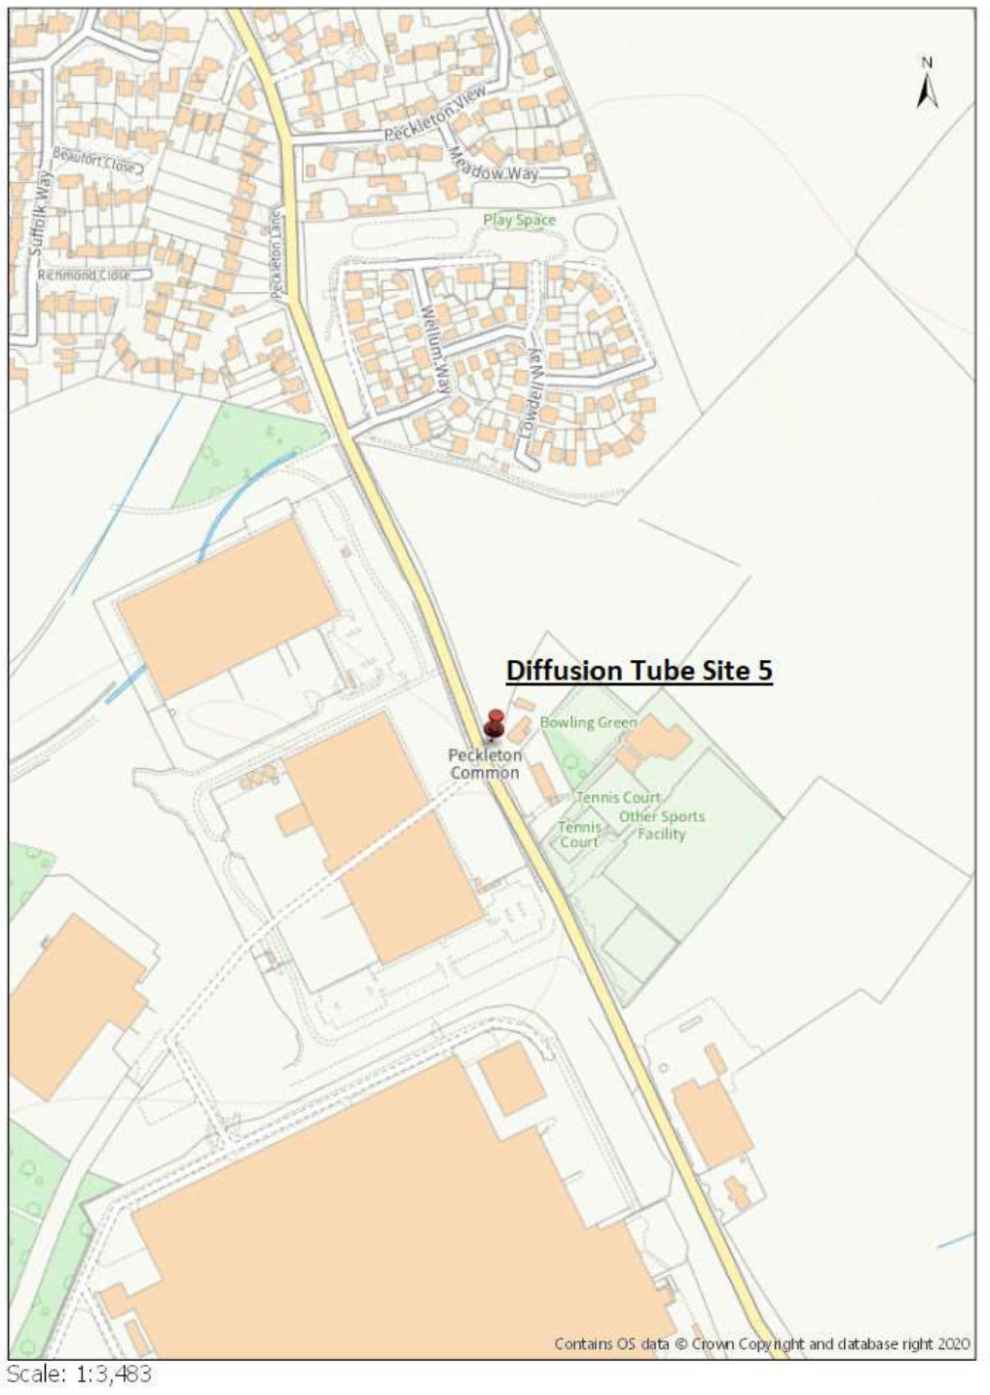
Map 5. Site 6: 207 Rugby Road, Burbage
Map 6. Site 7: 66 London Road Hinckley
Map 7. Site 8: Wood Street, Earl Shilton

Map 8. Site 9: Earl Shilton Bypass

Map 9. Site 11: 216 Markfield Road, Groby

Map 10. Site 13: 36 Groby Road, Ratby

Map 11. Site 10, 12 and 14: 6 Shaw Lane Markfield
Map 12 Site 15: 93 Rugby Road, Hinckley (Blue Pin) Site 16: 171 Rugby Road Hinckley (Red Pin)

Map 12 Map showing an overview of the diffusion tube network
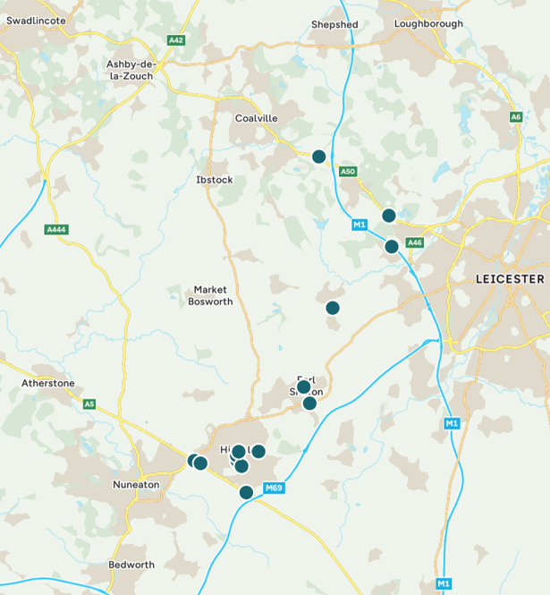

Appendix E: Summary of Air Quality Objectives in England
Table E.1 – Air Quality Objectives in England
Pollutant | Air Quality Objective: Concentration | Air Quality Objective: Measured as
Nitrogen Dioxide (NO₂) | 200µg/m³ not to be exceeded more than 18 times a year | 1-hour mean
Nitrogen Dioxide (NO₂) | 40µg/m³ | Annual mean
Particulate Matter (PM₁₀) | 50µg/m³, not to be exceeded more than 35 times a year | 24-hour mean
Particulate Matter (PM₁₀) | 40µg/m³ | Annual mean
Sulphur Dioxide (SO₂) | 350µg/m³, not to be exceeded more than 24 times a year | 1-hour mean
Sulphur Dioxide (SO₂) | 125µg/m³, not to be exceeded more than 3 times a year | 24-hour mean
Sulphur Dioxide (SO₂) | 266µg/m³, not to be exceeded more than 35 times a year | 15-minute mean

Glossary of Terms
Abbreviation | Description
AQAP | Air Quality Action Plan - A detailed description of measures, outcomes, achievement dates and implementation methods, showing how the local authority intends to achieve air quality limit values’
AQMA | Air Quality Management Area – An area where air pollutant concentrations exceed / are likely to exceed the relevant air quality objectives. AQMAs are declared for specific pollutants and objectives
ASR | Annual Status Report
Defra | Department for Environment, Food and Rural Affairs
DMRB | Design Manual for Roads and Bridges – Air quality screening tool produced by National Highways
LAQM | Local Air Quality Management
NO₂ | Nitrogen Dioxide
NO_{x} | Nitrogen Oxides
PM₁₀ | Airborne particulate matter with an aerodynamic diameter of 10µm or less
PM_{2.5} | Airborne particulate matter with an aerodynamic diameter of 2.5µm or less
QA/QC | Quality Assurance and Quality Control
SO₂ | Sulphur Dioxide

References
- Local Air Quality Management Technical Guidance LAQM.TG22. August 2022. Published by Defra in partnership with the Scottish Government, Welsh Assembly Government and Department of the Environment Northern Ireland.
- Local Air Quality Management Policy Guidance LAQM.PG22. August 2022. Published by Defra in partnership with the Scottish Government, Welsh Assembly Government and Department of the Environment Northern Ireland.
- Chemical hazards and poisons report: Issue 28. June 2022. Published by UK Health Security Agency
- Air Quality Strategy – Framework for Local Authority Delivery. August 2023. Published by Defra.
- DEFRA (2008) Background Air Quality Pollutant Maps.
http://laqm.defra.gov.uk/review-and-assessment/tools/background-maps.html
- Defra LAQM website: http://laqm.defra.gov.uk
- HBBC (2015) Air quality detailed assessment 2015
- HBBC (2016) Environmental permitting public register: http://www.hinckley-bosworth.gov.uk/downloads/file/871/environmental_permitting_public_register_updated_24_february_2016
- HBBC (2023) Annual Status Report 2025. Hinckley & Bosworth Borough Council June 2023. http://www.hinckley-bosworth.gov.uk/downloads/download/95/air_quality_progress_report_2010
- HMSO (2002) The Air Quality (England) (Amendment) Regulations 2002 Statutory Instrument 3043. ISBN 0 11044220 2, Her Majesty’s Stationery Office Publication.
- Laxen and Marner (2003) Analysis of the Relationship between 1-Hour and Annual Mean Nitrogen Dioxide at UK Roadside and Kerbside Monitoring Sites. Available form DEFRA, 2007b.
- Leicestershire County Council: (2014) Hinckley Area Project: http://www.leics.gov.uk/hinckley_area_project
- Leicestershire County Council: (2024) Leicestershire’s Local Transport Plan 4: Local Transport Plan (LTP4) | Leicestershire County Council
- Office for Health Improvement & Disparities. Public Health Profiles. 2026 © Crown copyright 2026

Defra. Air Quality Strategy – Framework for Local Authority Delivery, August 2023
The units are in microgrammes of pollutant per cubic metre of air (µg/m³).

