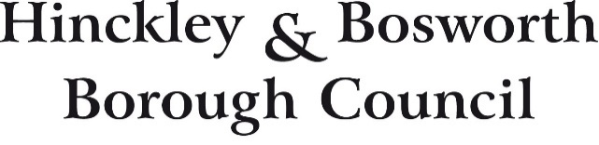

**AUDIT OF ACCOUNTS YEAR ENDED 31 MARCH 2025**

**NOTICE OF PUBLIC RIGHTS**

**The Accounts and Audit Regulations 2015**

**Local Audit and Accountability Act 2014**

Notice is hereby given under Regulation 15(2)(b) of the Accounts and Audit Regulations 2015 that from 1 July 2025 to 11 August 2025 inclusive between 10.00a.m. and 4.00p.m. on weekdays any person may inspect, and make copies of the accounts and all books, deeds, contracts, bills, vouchers, receipts and other related documents of the above-named body for the year ended 31 March 2025, as stipulated in Section 25 of the Local Audit and Accountability Act 2014.

The accounts and other documents will be available for inspection at offices at which they are normally kept by prior arrangement. Application should be made initially to Mr Ilyas Bham, Deputy Section 151 Officer (see contact details below). The accounts will also be available on the Hinckley and Bosworth Website <https://www.hinckley-bosworth.gov.uk/downloads/download/259/statement_of_accounts>

During this period, a local government elector for any area to which the accounts relate, or their representative, may question the auditor about the accounts, or make an objection to the accounts as set out in sections 26 and 27 of the Local Audit and Accountability Act 2014. Any objections, and the grounds on which it is made, must be sent to the auditor in writing, with a copy to Mr Ashley Wilson, Section 151 Officer (see address below). Any objection must state the grounds on which the objection is being made and particulars of:

1. any item of account which is alleged to be contrary to law; and
2. any matter in respect of which it is proposed that the auditor could make a public interest report under section 24 of, and paragraph 1 of Schedule 7 to, the Local Audit and Accountability Act 2014.

Objections should be addressed to the auditor, Mr Chris Brown, Head of Public Sector Audit – UK, Public Sector External Audit, Azets, 6th Floor Bank House, Cherry Street, Birmingham B2 5AL.

A guide to your rights can be found on the [National Audit Office website](https://www.nao.org.uk/code-audit-practice/wp-content/uploads/sites/29/2015/03/Council-accounts-a-guide-to-your-rights.pdf)

The accounts issued on 30 June 2025 are unaudited and may be subject to change.

Contact details.

|  |  |
| --- | --- |
| Mr Ilyas Bham  Deputy Section 151 Officer  Hinckley and Bosworth Borough Council  Hinckley Hub, Rugby Road, Hinckley, Leics LE10 0FR.  [Ilyas.bham@hinckley-bosworth.gov.uk](mailto:Ilyas.bham@hinckley-bosworth.gov.uk)  Telephone 01455 255 924. | Mr Ashley Wilson  Section 151 Officer  Hinckley and Bosworth Borough Council  Hinckley Hub, Rugby Road, Hinckley, Leics LE10 0FR.  [ashley.wilson@hinckley-bosworth.gov.uk](mailto:ashley.wilson@hinckley-bosworth.gov.uk)  Telephone 01455 255609. |