

# Annual complaints performance and service improvement report 2024-25

## Foreword from the Member Responsible for Complaints

I am proud to present the annual complaints performance and service improvement report for 2024/25.

Hinckley & Bosworth Borough Council has continued its excellent work in dealing with complaints, and the increase in complaints received demonstrates our desire to welcome and learn from complaints, continuously improving our services and providing support for our residents.

The new complaints policy has been embedded in the culture of the organisation during 2024/25, staff awareness sessions and training have taken place and the Ethical Governance and Personnel Committee have had sight of more information and outcomes from ombudsman investigations which has helped to raise the profile of complaints and ensure members are aware of the processes in place.

I have been pleased to be kept abreast of work being undertaken within the housing service to examine the outcomes of each complaint in detail to extract any learning. This support the vast amount of work taking place with and for tenants to ensure a positive experience and a successful relationship.

As Member Responsible for Complaints, I look forward to continuing to work with officers to ensure the complaints process retains its high profile within the authority and that appropriate information is provided to members and the relevant committees in relation to complaints.

Councillor Stuart Bray

Leader of the Council and Executive Member for Corporate Services

## Contents

1. Introduction

2. Complaint handling performance

3. Analysis of complaints upheld or upheld in part

4. Service improvements as a result of complaints

5. Compensation paid

6. Complaints refused

7. Findings of the Ombudsmen

8. Compliments

9. Complaint handling codes

10. Self-assessment

11. Review of actions from 2023/24 annual report

12. Future actions

## 1. Introduction

1.1 The council has a positive complaints culture and recognises that complaints are a valuable way of gaining feedback and driving service improvements**.**

1.2 Corporate complaints are managed by Democratic Services. References within this report to the complaints team are references to the Democratic Services team. The team manages and co-ordinates corporate complaints and complaints about the council as landlord and is the link officer for the Local Government & Social Care Ombudsman and the Housing Ombudsman.

1.3 The council has a two-stage complaints process. Stage 1 complaints are usually investigated by the line manager of the officer who has been handling the case or is the subject of the complaint. At stage 2, complaints are investigated by an officer senior to or independent from the officer who completed the stage 1 investigation. As part of the stage 2 response, complainants are provided with the contact details for the relevant ombudsman, should they remain dissatisfied.

1.4 Complaints are invited via any method to ensure the process is accessible. For those accessing the information on the council’s website, the website meets accessibility requirements, being consistently rated one of the top in the country by Silktide.

## 2. Qualitative and quantitative analysis of our complaint handling performance

### 2.1 Summary of all complaints received in 2024/25

The complaints team received and processed 236 complaints in 2024/25. This is an increase on previous years which can be attributed to cultural changes to invite complaints at an earlier stage in accordance with the Housing Ombudsman’s complaint handling code and the council’s new complaints policy which was adopted in May 2024.

*Table 1: number of complaints per year for the last six years*

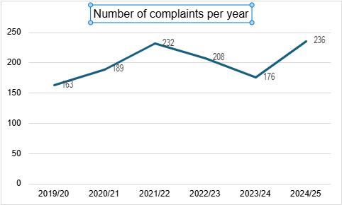

### 2.2 Complaints by service area

*Table 2: complaints by service area*

### A pie chart to show the number of complaints registered, broken down by service area

### 2.3 Complaints about the council as landlord

In 2024/25, the council as landlord received 81 complaints (of the 116 for Housing & Community Safety shown in table 2). This is an increase on the 34 complaints received about the council as landlord in 2023/24. The large increase can be attributed to the new complaints policy which requires any expression of dissatisfaction to be recorded as a complaint and the work that has been undertaken within the housing service to promote the complaints process and to encourage and support tenants to submit a complaint.

These complaints received about the council as landlord can be broken down as follows:

*Table 3: complaints about the council as landlord*

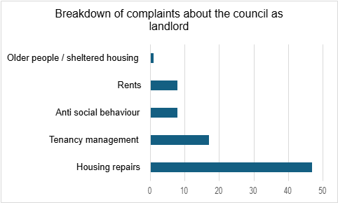

### 2.4 Stage 2 complaints

57 complaints (of the total 236) were escalated to stage 2. Of the 81 complaints about the council as landlord, 16 were escalated to stage 2.

### 2.5 Performance in relation to complaint handling

Of the 236 stage 1 complaints, two were withdrawn and one remains outstanding. 95.7% of the remaining stage 1 complaints and 70.2% of stage 2 complaints received a response within the stated 20 working days.

In relation to complaints about the council as landlord, 96.3% of stage 1 complaints and 75% of stage 2 complaints received a response within the stated ten working days.

## 3. Analysis of complaints upheld or upheld in part

### 3.1 All complaints

Of the 236 complaints, 113 were upheld or upheld in part at stage 1 and / or stage 2. This equates to 48% and is an increase on the 43% upheld/upheld in part in 2023/24. This shows that the council is keen to acknowledge where services could be improved and to use learning from complaints to drive service improvements. It should be noted that the outcome “upheld in part” covers complaints for which only one aspect has been upheld, which may not be the substantive part of the complaint.

*Table 4: upheld / part upheld complaints by service area:*

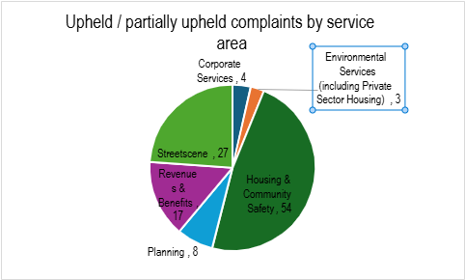

3.2 Of the 113 complaints upheld / upheld in part for Housing & Community Safety, 42 were complaints about the council as landlord. These are addressed separately in paragraph 3.3. Of the remaining 66 corporate complaints upheld or upheld in part, the following general themes have arisen (although this isn’t necessarily the aspect for which fault was accepted):

* Unhappy with a decision (eight complaints)
* Delays in processing (four complaints)
* Errors made (28 complaints)
* Lack of communication, behaviour of officer or poor case management (31 complaints).

### 3.3 Complaints about the council as landlord

There were 42 complaints about the council as landlord that were upheld or upheld in part. 27 related to repairs, seven to tenancy management, five to rents and three to anti social behaviour. As the area with the most complaints, a breakdown of nature of housing repairs complaints that were upheld or upheld in part can be seen in table 5.

*Table 5: housing repairs complaints upheld / upheld in part*

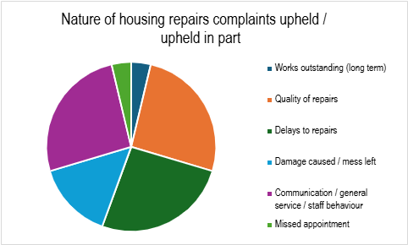

## 4. Service improvements as a result of complaints

4.1 The following service improvements have been made as a result of corporate complaints:

* An increase in financial assistance with rental for a particular household type was agreed following a complaint about the increase in cost of private rental properties meaning that the assistance provided was insufficient to meet the six month stability criteria. This aims to reduce homelessness and reliance on temporary accommodation
* The planning service agreed improvements to the information they convey when closing an enforcement case to ensure the final position was clear
* Data protection training was provided to an officer following a letter being sent to the incorrect address
* Following a complaint about the way an applicant was made to feel by objectors at Planning Committee, the chair’s script was updated to include a reminder about respecting each other’s views. This will also be included in information provided when speakers register
* As a result of a complaint about parking problems in a residential area caused by a group using one of the council’s community houses, the service was moved to a more suitable venue with off-road parking
* Having received a complaint about delays in the mutual exchange process, it was agreed that processing of mutual exchanges, including timescales and communication, would be reviewed
* Procedures for holding photos of events were reviewed in response to a complaint about use of a photograph that should have been deleted
* Processes were implemented for more thorough checks on eligibility of applicants for the household support fund prior to them taking the time to apply
* The process for keeping victims of anti social behaviour were reviewed to ensure victims were kept fully informed and in a position to challenge and influence decisions about their case.

4.2 The following service improvements have been made as a result of complaints about the council as landlord:

* Following a complaint from a tenant after being informed that they had missed an appointment to carry out a gas inspection, it was agreed that the process would be reviewed with the intention of contacting tenants earlier in the process
* In relation to a complaint about a housing move due to a regeneration project, it was agreed that a single officer would be involved in reviewing claims for costs to ensure consistency and that there would be improved communication with tenants in these circumstances in future
* As a result of a complaint about one of the council’s contractors, operatives were reminded about standards of behaviour expected
* Actions were agreed to improve communication between housing teams and the tenant in relation to repairs and issues raised following the works
* Following a complaint about lack of action in relation to anti social behaviour caused by a tenant, it was acknowledged that improved communication with the complainant would have ensured they were reassured of actions being taken, albeit without being able to provide detail. This would be taken into account in similar situations in future. In this particular case, it was agreed that a senior officer would maintain oversight of the case
* A complaint about the harsh wording of an anti social behaviour warning letter resulted in the templates being reviewed and the team being reminded to ensure letters did not appear threatening
* Housing repairs officers were reminded to check the repair history of a property before raising an order for work following a complaint about duplicate jobs being raised
* The behaviour of a contractor was being monitored following two complaints about the same operative
* A complaint about a contractor’s call handler led to the council’s expectations in relation to customer service being refreshed with the contractor
* Processes have been put in place to identify repeat call-outs rather than logging them as new repair requests – in the instance of the complaint that led to this improvement, the boiler was replaced as it was identified that eight call-outs within less than six months was unacceptable and officers should have noted the pattern and resolved the issue sooner
* Tenancy management officers were reminded to be clear in correspondence when allegations have been received that these are allegations and not an outcome of the council’s investigation into any allegations
* Following an injury sustained due to debris placed on a footpath during remedial works, the council’s health and safety officer undertook an investigation, the learning from which has been included in training for operatives going forward.

## 5. Compensation

5.1 Where fault and injustice are found and this can be quantified, compensation may be offered as a result of a stage 1 or 2 complaint. This section lists where compensation has been offered – in some cases this is funded by the contractor and not by the council.

5.2 Following a complaint about delays in receiving pre-planning advice and lack of communication in the meantime, the pre-application fee was refunded in full.

5.3 A tenant complained about damage caused during works to their property. £300 compensation was offered to cover the cost of redecorating, along with the council offering to cover the cost of carpet cleaning.

5.4 Following a complaint that one of the council’s contractors had caused damage to garden ornaments, the contractor compensated the tenant at the council’s request.

5.5 One of the council’s contractors paid compensation of £150 to a tenant to cover loss of earnings following complaints that the tenant had had to take time off work repeatedly to allow the contractor access to their property to resolve issues caused by the contractor.

5.6 A refund of 50% of a building control inspection was issued following a complaint about incorrect advice being provided.

5.7 Due to inconvenience caused to a tenant as a result of repeated call-outs to a boiler fault, it was agreed that bathroom flooring be installed at the council’s expense by way of an apology.

5.8 Following damage caused to electronic equipment after a ceiling fell, compensation of £200 was issued to a tenant.

5.9 As a result of damage to a rug and bedroom carpet caused by the council’s contractor, compensation was offered by the contractor.

## 6. Complaints refused

6.1 No complaints were refused for reasons set out in the complaints policy during 2024/25.

## 7. Findings of the Ombudsmen

7.1 Local Government & Social Care Ombudsman

During 2024/25, the Local Government & Social Care Ombudsman dealt with 15 complaints about the council. One is still outstanding and the final decision is awaited. Three were rejected as being out of jurisdiction, 11 were closed after initial assessment and one was investigated.

Complaint 23 009 862: This was a complaint about the council’s consideration of planning applications, failure to take enforcement action and delayed complaint responses. The Ombudsman found fault which caused the complainant frustration, time and trouble but considered an apology (which had already been issued during the complaints process) and a symbolic payment of £250 in recognition of the complainant’s avoidable frustration sufficient remedy. The remedy was completed with the Ombudsman’s timescales.

7.2 The annual report of the Local Government & Social Care Ombudsman is attached.

7.3 Housing Ombudsman

During 2024/25, we were contacted about three complaints by the Housing Ombudsman. Two complaints were investigated and an outcome is awaited. Initial comments were submitted on the third complaint and notification about whether they are investigating is awaited.

7.4 The annual report of the Housing Ombudsman has not yet been received.

## 8. Compliments

8.1 Nine compliments were recorded in 2024/25:

* Street Scene Services: refuse collectors “going over and above” to clear litter from the area
* Housing: thanks to an individual officer for additional support with a housing application
* Welfare support: thanks to an officer for their support
* Unknown service area: thanks for a simple and understandable service
* Control Centre: situation dealt with efficiently
* Democratic Services: complaint about a road closure dealt with very comprehensively
* Housing: excellent work of an officer to keep people in the loop and for being proactive
* Street Scene Services: thanks to the refuse collectors for returning to collect a bin
* Private Sector Housing: thanks to an officer for advice, information and support and for going out of his way to help.

## 9. Complaint handling codes

9.1 In February 2024 the Local Government & Social Care Ombudsman and the Housing Ombudsman issued new complaint handling codes. Whilst separate, the two codes follow the same principles. The Housing Ombudsman’s code applies to any complaint about the council as landlord, it is statutory and came into force on 1 April 2024, whereas the Local Government & Social Care Ombudsman’s code is guidance to which we must have regard, and complaints will be considered against the code from April 2026.

9.2 In pursuance of the new codes, the Ethical Governance & Personnel Committee approved a new complaints policy on 20 May 2024. In order to comply with the implementation date of 1 April for the Housing Ombudsman’s complaint handling code, the council implemented those changes that were possible without having approved a new policy prior to 1 April. It is our view that we were compliant with the complaint handling code from 1 April and all complaints were dealt with in accordance with the new code.

9.3 The council has complied with the requirement to have a policy in place and will comply with the requirement to publish an annual report and self-assessment by the end of June 2025.

## 10. Self-assessment

10.1 Self-assessment is a requirement of the complaint handling codes. Our self-assessment against the Housing Ombudsman’s code is appended to this report. A self-assessment against the Local Government & Social Care Ombudsman’s code will be included when this becomes a requirement and a template is available.

## 11. Review of actions outlined in 2023/24 annual report

11.1 In order to comply with the new code and the council’s new policy, data on types of complaints refused has been recorded.

11.2 All decisions of the Ombudsmen where fault is found have been reported to the Ethical Governance & Personnel Committee.

11.3 The Member Responsible for Complaints has been kept updated on complaint handling performance and decisions of the Ombudsmen and has ensured the Ethical Governance & Personnel Committee has received any necessary information.

11.4 Refreshed complaint handling training has been provided for all staff who deal with stage 1 or 2 complaints. Training for frontline staff who may take calls from complainants is yet to be arranged, however guidance notes have been provided.

## 12. Future actions

12.1 Training for frontline staff who may take calls from complainants will be arranged.

12.2 A pilot satisfaction survey for complaints about the housing service has been launched and is currently being reviewed by tenants.

12.3 A compensation and remedy policy will be produced during 2025/26.

Appendices:

Local Government & Social Care Ombudsman’s annual letter (appendix A)

Self-assessment against the Local Government & Social Care Ombudsman’s complaint handling code (appendix B)

Self-assessment against the Housing Ombudsman’s complaint handling code (appendix C)