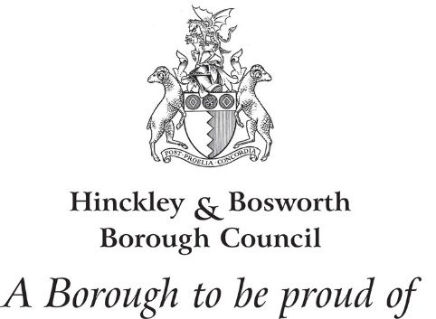
Bill Cullen MBA (ISM), BA(Hons) MRTPI

Chief Executive

Please Ask For: Bill Cullen
Direct Dial/Ext: 01455 255737
Email: bill.cullen@hinckley-bosworth.gov.uk
Your Ref:
Our Ref: Leicestershire Market Towns Group
Date: 18 November 2025

By email :

Dear ……………….

Impact of changes to Business Rates Relief (BRR)

We are writing to you to express the adverse impact of the changes to Business Rates Relief on small businesses across Leicestershire.

Since the October budget, and the announcement that the Retail, Hospitality and Leisure Relief (RHLR) scheme would reduce from a 75% discount in April 2025 to a 40% discount until April 2026, small business owners in our county are fearful they will face considerable hardship. As the Leicestershire Market Towns Group, we are lobbying on their behalf.
The Leicestershire Market Towns Group has calculated that around £26m of rates relief has been lost in Leicester and Leicestershire by this single policy change (refer to attached document for a breakdown of numbers of businesses affected and total loss per constituency). The average loss per business is almost £3,000.

It is important to appreciate this is not an isolated issue. It comes on top of other changes, all of which have significantly impacted the profitability of businesses, including:

- Changes to National Insurance and minimum wage rises (in hospitality 46% of workers earn minimum wage and around half are under 25)
- Changes in consumer behaviour since the pandemic that has seen reduced footfall on our high streets with physical retailers losing trade to the digital economy
- Inflation increasing costs of ingredients and utilities for hospitality venues

The changes to BRR, set against the economic backdrop described above, will create increased anxiety and significant pressure for small business owners trying to remain present on our high streets. All these rising costs have a significant impact on profit margins and, when the focus is on survival, there is limited investment in business growth and employment. It is widely acknowledged that small business owners, particularly those in the independent sector, will be hardest hit by these policy changes. Some hospitality venues have indicated that regardless of how busy they are, they might not be making enough operational profit to survive. The British Beer and Pub Association recently revealed that landlords make 12p profit per pint.
The detrimental impact these pressures will have on your constituency include business failures on the high street and subsequent job losses. The British Beer & Pub Association (BBPA) released data earlier this year that reveals six pubs a week are shutting their doors for good. ONS data released on 12 August shows that hospitality has been the hardest hit sector of the economy since the Budget, accounting for 53% of all job losses in the UK. The impact this will have on high streets, and the communities that use and depend on them, could be devastating. As was stated in the 2024 House of Lords Built Environment Committee report High Streets: Life beyond retail? local high streets are at the very heart of communities. They provide vital social and economic infrastructure and so need to be supported to thrive and flourish.

We believe that overhauling business rates for the Retail Hospitality & Leisure sector would slow down unnecessary business failures and reduce the huge financial pressures faced by many small business owners. In the October budget, Government announced plans to transform the business rates system to make it fairer and make sure it “protects the high-street, supports investment and is fit for the 21st century”. We are asking our Leicestershire MPs to advocate for our small businesses by:

- Addressing the inequality of business rates through a fundamental reform of the system, to balance the financial pressures on physical retailers with the realities of an increasingly digital economy
- Making the case for a permanently reduced rate for RHL properties (rather than changing every 12 months), to encourage longer term financial planning
- Give consideration as part of this reform to the immensely valuable work of our Business Improvement Districts whose levies are linked to business rates. It is vital that any reform does not disadvantage those who do so much to champion our high streets.
- Introducing policies to encourage more growth and investment by smaller businesses

Finally, we ask you to read the testimonies of some of our Leicestershire small business owners in the attached document.

Members of the Leicestershire Market Towns Group would be very happy to meet with you to discuss this matter in more detail (email sally.coleman@leics.gov.uk to facilitate this).

Yours sincerely
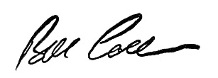

Bill Cullen
Chair of Market Towns Group

- Ashby de la Zouch Business Improvement District
- Blaby District Council representing Blaby Town Centre
- Hinckley & Bosworth Borough Council representing Barwell, Earl Shilton and Market Bosworth
- North West Leicestershire District Council representing Coalville
- Hinckley Business Improvement District (BID)
- Love Loughborough (Loughborough BID)
- Harborough District Council representing Market Harborough and Lutterworth
- Melton Mowbray Business Improvement District
- Oadby & Wigston Borough Council representing Oadby and Wigston Town Centres

The Leicestershire Market Towns Group, chaired by the Chief Executive of Hinckley & Bosworth Borough Council is a network of town centre and Business Improvement District managers, neighbourhood police representatives and local authority officers.

